Investor Sentiment Dynamics, the Cross-section of Stock Returns and the MAX Effect

Muhammad A. Cheema
School of Accounting, Finance and Economics
University of Waikato
Hamilton, New Zealand
Email: muhammad.cheema@waikato.ac.nz

Gilbert V. Nartea
Department of Economics and Finance
UC Business School
University of Canterbury
Christchurch, New Zealand
Email: gilbert.nartea@canterbury.ac.nz

This version: May 2018

Investor Sentiment Dynamics, the Cross-section of Stock Returns and the MAX Effect

Abstract
Recent evidence shows that investor sentiment is a contrarian predictor of stock returns with speculative stocks earning lower (higher) future returns than safe stocks following high (low) sentiment states. We extend this argument by conditioning expected stock returns on sentiment dynamics and show that the mispricing of speculative and safe stocks worsens with sentiment continuations but is corrected with sentiment transitions, consistent with the view that the mispricing of these stocks is sentiment-driven. We show that the unconditional contrarian return predictability of sentiment, at least in the short-run, is due to the returns of stocks in sentiment transitions. Results show that ex post, sentiment is a momentum predictor if subsequent sentiment continues; and a contrarian predictor if subsequent sentiment transitions. We also show that the MAX effect can either be positive or negative contingent on sentiment dynamics and that the absence of a MAX effect following Low sentiment states suggested by prior studies is due to the completely offsetting negative MAX effect when sentiment continues in a Low state, and the positive MAX effect when sentiment transitions from a High to a Low state.

I. Introduction

Investor sentiment (sentiment hereafter) refers to the propensity of investors to speculate. Several studies have long considered the possibility that sentiment has an impact on stock market returns which causes stock prices to divert from their fundamental values (e.g. Keynes, 1936; Shiller, 1981; Campbell & Shiller, 1988; Fama & French, 1988; Poterba & Summers, 1988; Fama & French, 1989; De Long, Shleifer, Summers, & Waldmann, 1990). Furthermore, Baker and Wurgler (2006) show that the sentiment related mispricing is more persistent in stocks that are hard to value and difficult to arbitrage, e.g., high volatility, young, small, unprofitable, and non-dividend paying stocks. Several studies have shown that the abnormal returns of stock market anomalies are related to mispricing caused by sentiment. For example, Fong and Toh (2014) show that the negative MAX effect exclusively follows high sentiment periods suggesting that the MAX effect is sentiment driven. Shleifer and Vishny (1997) suggest that mispricing can persist for extended periods when rational investors become reluctant to intervene to bring stock prices back to their fundamental values as they avoid noise trader risk that can worsen the mispricing.
In this paper, we extend Baker and Wurgler’s (2006) argument by introducing noise trader risk through sentiment dynamics -- whether sentiment continues in the same state or transitions to a different state. If the mispricing of stocks is sentiment-driven, we expect, in a two-state sentiment scenario, for the mispricing to worsen if sentiment continues in the same state and for the mispricing to be corrected when sentiment transitions to the other state. In other words, we expect the overpricing (underpricing) of hard to value and hard to arbitrage (HVHA) stocks relative to easy to value and easy to arbitrage (EVEA) stocks to worsen if sentiment continues in the High (Low) state. In contrast, we expect a correction of the overpricing (underpricing) when sentiment transitions from a High (Low) to a Low (High) state.
Bali et al. (2011) find that high MAX stocks are small or illiquid, making them HVHAstocks. Therefore, to the extent that the MAX effect is the result investor optimism during high sentiment periods as argued in Fong and Toh (2014), we suggest that the overpricing of high MAX stocks in High sentiment periods is corrected only when the subsequent sentiment decreases while the mispricing worsens because of noise traders if sentiment continues in a high state. Therefore, the negative MAX effect following High sentiment periods would obtain only when sentiment transitions to a Low state. Furthermore, following Baker and Wurgler (2006) we argue that high MAX stocks are underpriced in Low sentiment periods; therefore, we also expect a negative MAX effect when the subsequent sentiment continues to decrease, as high MAX stocks remain underpriced because of noise trader risk.
Using both survey and market-based measures of investor sentiment, we find that subsequent returns of HVHA stocks continue to remain high (low) relative to EVEA stocks if the subsequent sentiment continues to increase (decrease). In contrast, we find that HVHA stocks earn lower (higher) returns relative to EVEA stocks following High (Low) sentiment periods, as suggested by Baker and Wurgler (2006, 2007), but only when the subsequent sentiment transitions to a Low (High) state. These results support the view that the mispricing of HVHA and EVEA stocks is sentiment-driven and it highlights the important role of noise trader risk and the difficulty of trading on sentiment-induced mispricing especially in the short-run. Furthermore, we find a negative MAX effect when sentiment transitions from a High to a Low state or when sentiment continues to be Low. In contrast, we find a positive MAX effect when sentiment continues to be High or when it transitions from a Low to a High state. We also show that the absence of a MAX effect following Low sentiment states is due to the completely offsetting negative MAX effect generated by sentiment continuation in Low state by the positive MAX effect when sentiment transitions from a Low to a High state.
We contribute to the literature in two ways. First, we extend the analysis of Baker and Wurgler (2006, 2007) by explicitly considering noise trader risk, and provide further evidence supportive of the view that the mispricing of HVHA and EVEA stocks is driven by investor sentiment. Second, we show the importance of considering sentiment dynamics when examining stock market anomalies. As far as we know, we are the first to show that the MAX effect can either be negative or positive depending on sentiment dynamics, providing further support to the view that the MAX effect is a sentiment driven mispricing.
Section II develops the hypotheses, Section III describes the data, in particular our proxies for investor sentiment and HVHA stocks, Section IV provides the empirical results, Section V applies robustness tests and the last section concludes
II Development of Hypotheses
The prevailing consensus is that investor sentiment is a contrarian predictor of stock returns over long horizons (Baker & Stein, 2004; Brown & Cliff, 2005; Schmeling, 2009; Baker, Wurgler, & Yuan, 2012) as sentiment wanes and fundamentals are revealed; or when potential arbitrage profits reach a level at which arbitrageurs find it profitable to bear noise trader risk (i.e., the variability of investor sentiment) (e.g. De Long et al., 1990; Shleifer & Vishny, 1997) and act to restore prices back to fundamental value (Baker et al., 2012). However, the evidence on short-term return predictability of investor sentiment is still contentious. Fisher and Statman (2000) find that investor sentiment is a reliable contrarian predictor of subsequent month market returns using the S&P 500 as a proxy for the market. In contrast, Brown and Cliff (2004) do not find any significant predictive ability for sentiment in relation to weekly and monthly market returns. Meanwhile, Huang, Jiang, Tu, and Zhou (2014) find that investor sentiment is a contrarian predictor of market returns over both short and long horizons. Berger and Turtle (2015) suggest that short-run increases in sentiment are followed by increased returns while prolonged episodes of increasing sentiment are followed by negative returns. In a related paper, Han and Li (2017) show that investor sentiment is a momentum predictor of market returns at short horizons but a contrarian predictor at long horizons in China.
Baker and Wurgler (2006) argue that investor sentiment has cross-sectional effects on stock prices and show that investor sentiment does not raise or lower prices of all securities equally, instead its impact is more pronounced in stocks that are hard to value and difficult to arbitrage (HVHA) relative to easy to value and easy to arbitrage (EVEA). In particular, they find that over relatively long horizons, HVHA stocks such as high volatility, young, small, unprofitable, and non-dividend paying stocks earn relatively lower (higher) returns following High (Low) sentiment periods, which suggest that HVHA stocks are relatively overpriced (underpriced) during High (Low) sentiment periods.
Subsequently, Baker and Wurgler (2007) show that their index of sentiment changes is positively related to both contemporaneous market and stock portfolio returns indicating that HVHA stocks are indeed overpriced (underpriced) relative to EVEA stocks during High (Low) sentiment periods. Furthermore, Baker and Wurgler show that their index of sentiment levels is a contrarian predictor of returns even in short (one-month) horizons, with the impact of investor sentiment still more pronounced in HVHA stocks though it is modest for aggregate market returns. They then hint at the possibility of a profitable trading strategy from the contrarian predictability of sentiment levels index.
Based on the efficient market hypothesis, mispricing cannot persist because rational arbitrageurs can force stock prices back to their fundamental values by taking a position against the mispricing (Fama, 1965). However, Shleifer and Vishny (1997) suggest that arbitrageurs might not be able to entirely eliminate the mispricing due to the risk that noise traders might push prices even further away from their fundamental values especially when the sentiment deepens.
We extend Baker and Wurgler’s (2006, 2007) argument by introducing noise trader risk through sentiment dynamics -- whether sentiment continues in the same state or transitions to a different state. If the mispricing of stocks is sentiment-driven, we expect, in a two-state sentiment scenario, for the mispricing to worsen if sentiment continues in the same state and for the mispricing to be corrected when sentiment transitions to the other state. In other words, we expect the overpricing (underpricing) of HVHA stocks relative to EVEA stocks to worsen if sentiment continues in the High (Low) state. In contrast, we expect a correction of the overpricing (underpricing) when sentiment transitions from a High (Low) to a Low (High) state. For example, if the current High (Low) sentiment continues in the subsequent period, then we expect returns of HVHA stocks to be higher (lower) than EVEA stocks as noise traders push prices further away from fundamental values. In contrast, if the current High (Low) sentiment transitions in the subsequent period, then we expect returns of HVHA stocks to be lower (higher) than EVEA stocks.
Therefore, to the extent that the overpricing or underpricing of stocks is sentiment-driven our first hypothesis is:
H1: The average future returns of HVHA stocks would be higher (lower) than EVEA stocks if sentiment continues in the High (Low) state. As a corollary, the average future returns of HVHA stocks would be lower (higher) than EVEA stocks if the subsequent sentiment transitions to a Low (High) state.
In accord with our first hypothesis, we conjecture that the unconditional short-run contrarian return predictability of sentiment as suggested by Baker and Wurgler is the consequence of low or negative stock returns, when sentiment transitions from High to Low, dominating the high or positive returns when sentiment continues in the High state; hence stock returns are low following High sentiment states since in general stocks are overpriced in the High sentiment state. Similarly, we posit that the high or positive stock returns when sentiment transitions from Low to High, dominates the low or negative returns when sentiment continues in the Low state; hence returns are high following Low sentiment states since in general stocks are underpriced in the Low sentiment state.
We suggest that our framework of combining investor sentiment and noise trader risk can explain return patterns of certain stock anomalies that are based on HVHA stocks such as, the ‘negative MAX effect’. Bali et al. (2011) document a negative MAX effect in which stocks with the highest maximum returns (high MAX) over the past month exhibit lower subsequent returns relative to stocks with lowest maximum returns (low MAX) over the past month. They attribute this anomaly to investor preference for high MAX stocks resulting in an overpayment for such stocks, which when corrected in the subsequent period translates to lower returns. Moreover, Bali et al. (2011) find that high MAX stocks are small or illiquid, making them HVHA stocks. Meanwhile, Fong and Toh (2014) find that the negative MAX effect exclusively follows high sentiment periods suggesting that the MAX effect is sentiment driven. If the MAX effect is sentiment driven, we suggest that the overpricing of high MAX stocks in High sentiment periods is corrected only when the subsequent sentiment decreases; therefore, the negative MAX effect following High sentiment periods would obtain only when sentiment transitions to a Low state. Consequently, we expect a positive, (not negative) MAX effect when sentiment continues to increase as the overpricing of high MAX stocks worsens instead of it being corrected because of noise traders. Furthermore, following Baker and Wurgler (2006) we argue that high MAX stocks are underpriced in Low sentiment periods; therefore, we also expect a negative MAX effect when the subsequent sentiment continues to decrease, as high MAX stocks remain underpriced. In contrast, we expect a positive MAX effect when sentiment transitions from a Low to a High state as the underpricing of high MAX stocks is corrected, resulting in higher returns. Therefore, our second hypothesis is:
H2: The MAX effect is negative when sentiment transitions from High to Low or when sentiment continues to be Low. As a corollary, the MAX effect is positive or at least absent when sentiment continues to be High or when sentiment transitions from Low to High.
In line with our second hypothesis, we posit that the absence of a MAX effect following Low sentiment states as documented by Fong and Toh (2014), is due to a negative MAX effect when sentiment continues in a Low state, being completely offset by a positive MAX effect when sentiment reverses to a High state.
Table 1 summarises the predictions based on hypotheses 1 and 2.

III. Data: Investor Sentiment and Hard to Value Stocks
A. Investor Sentiment
We use both survey and market-based measures of investor sentiment to test whether the results are sensitive to the choice between market- or survey-based sentiment measures. Our first two measures of sentiment are Baker and Wurgler’s ‘sentiment levels’ index and ‘sentiment changes’ index. The sentiment levels index is estimated as the first principal component of the six different proxies of investor sentiment, namely the closed-end fund discount, NYSE share turnover, the number and average first-day return on IPOs, the equity share in new issues, and the dividend premium; whereas the sentiment changes index is estimated as the first principal component of changes in those six different proxies of investor sentiment. Baker and Wurgler (2007) suggest the use of the changes index rather than differencing the levels index since sentiment proxies have differential noisiness in going from levels to changes. Furthermore, they argue that their sentiment changes index is more suited for testing return comovement patterns associated with the changes in sentiment; while the sentiment levels index is more suited for testing return predictability conditioned on lagged sentiment levels. Therefore, we use the sentiment levels index (STM) to define lagged sentiment, and the sentiment changes index (▲STM) to define subsequent change in sentiment. A positive (negative) sentiment levels index and sentiment changes index defines a High (Low) sentiment state.
We use VIX as a third measure of sentiment. VIX is a measure of market expectations of near-term volatility (30-day) which is estimated in real time basis from at-the-money CBOE S&P500 index options. It is generally referred to in the literature as a gauge of investors’ fears so a high (low) value of VIX indicates fear (confidence) in the market and a decrease (increase) in contemporaneous market returns. We use a negative (positive) change in VIX to define a High (Low) sentiment state.
Our fourth sentiment indicator, the put-call ratio is derived from combined CBOE equity and index options. The put-call ratio is estimated by dividing the total trading volume of puts by the total trading volume of calls. A high put-call ratio indicates a bearish trend as investors buy more puts to hedge their position or to make bearish bets when the sentiment is negative. Similar to VIX, a negative (positive) change in the put-call ratio defines a High (Low) sentiment state. Several studies use VIX and/or put-call ratio as a proxy for investor sentiment (e.g. Whaley, 2000; Simon & Wiggins, 2001; Kurov, 2010)
We use the American Association of Individual Investors (AAII) sentiment survey as our final proxy of investor sentiment. The AAII asks survey participants their opinion on whether the market will be bullish, bearish or neutral in the next six months. A higher number of responses with bullish (bearish) views indicates optimism (pessimism) about the stock market. AAII defines the bull-bear spread (BBS) based on the difference in bullish and bearish views. A positive (negative) BBS in a month defines a High (Low) sentiment state. Several studies use the BBS as an investor sentiment proxy (e.g. Fisher & Statman, 2000; Brown & Cliff, 2004).
We collect data for the value-weighted market returns from CRSP. The Baker and Wurgler sentiment changes (▲STM) index and sentiment levels (STM) index are obtained from the website of Professor Jeffrey Wurgler. We obtain VIX data from DataStream International, the put-call ratio data is collected from the Chicago Board of Options Exchange (CBOE), and BBS data is obtained from the AAII’s website. The data period for the CRSP value-weighted market returns, sentiment changes index, sentiment levels index, VIX, put-call ratio and BBS starts from July 1964, August 1965, July 1965, January 1990, September 1995 and July 1987, respectively. All the data for sentiment proxies and CRSP value-weighted market returns end in December 2014.
Table 2 reports the summary statistics and correlation coefficients of CRSP value-weighted market returns and investor sentiment proxies used in this study. Panel A of Table 2 shows a mean (median) CRSP value-weighted market return over the sample period of 0.89% (1.13%), a mean (median) ▲STM index of 0.00 (0.00), a mean (median) STM index of 0.00 (0.05), a mean (median) average VIX of 19.96 (17.80), a mean (median) put-call ratio of 0.83 (0.84), and a mean (median) BBS of 8.57% (9.43%). There are 606 observations for CRSP value-weighted returns (VWRET), 593 for ▲STM index, 594 for STM index, 300 for VIX, 232 for the put-call ratio (PC), and 330 for BBS.
Panel B of Table 2 reports the correlation among the investor sentiment proxies and contemporaneous VWRET. Consistent with the literature (e.g. Brown & Cliff, 2004; Smales, 2017), we expect a positive correlation between investor sentiment and contemporaneous VWRET. The correlation between VWRET and ▲STM index is 0.19 which shows that ▲STM index is positively associated with VWRET which is consistent with our expectation because a positive (negative) ▲STM index indicates optimism (pessimism) in the market. The correlation between VWRET and STM is -0.05 which means that an increase in sentiment results in a decrease in VWRET; however, it is statistically insignificant. The insignificant correlation between VWRET and STM is not surprising since Baker and Wurgler (2007) suggest that the STM (sentiment levels) index is more suited for future stock return predictability; whereas the ▲STM (sentiment changes) index comoves with market returns. The correlation between VWRET and VIX (PC) is -0.26 (-0.25) which shows that an increase in VIX or PC results in a decrease in VWRET. The negative correlation between VWRET and VIX and PC is consistent with our expectation because high values of VIX and PC represent fear in the market. The correlation between VWRET and BBS is 0.19 which is consistent with our expectation as higher (lower) values of BBS indicate optimism (pessimism) in the market. In sum, the correlation between different proxies of investor sentiment, are in accord with our expectations.
B. Hard to Value and Hard to Arbitrage Stocks
In this section, we describe the proxies for hard to value and hard to arbitrage (HVHA) stocks. We define HVHA stocks based on their characteristics of profitability, dividend payment ability, and asset tangibility since these characteristics are often cited in the literature to have a straight-forward relationship with sentiment (e.g. Baker & Wurgler, 2006). We collect firm characteristic data from the merged CRSP-Compustat database from 1964 to 2014.
Table 3 shows summary statistics of firm-level data. Panel A reports monthly return and MOM variables. Following the literature, MOM is estimated at time t based on the cumulative return from t-12 to t-2 months. Following Baker and Wurgler (2006), we use MOM as a control variable only.
Panel B reports volatility, age and market equity (ME) variables. Volatility is the standard deviation of monthly returns over the past 12 months ending in June of year t. Age is estimated at time t based on the number of years since the firm first appears on CRSP. ME is measured from June of year t, and is matched to monthly returns from July of year t to June of t+1. High volatility, young and small size firms are defined as HVHA stocks.
Panels C to E report accounting data that are collected from fiscal year ends in the calendar year t-1, and are matched to monthly returns from July of year t to June of year t+1. Panel C reports the profitability variable, return on equity. Return on equity (E+/BE) is earnings over book equity. Earnings (E) is income before extraordinary item (item 18) plus income statement deferred taxes (item 50) minus preferred dividends (item 9). The book equity (BE) is shareholders equity (item 60) plus balance sheet deferred taxes (item 35). The E+/BE is positive for profitable firms and zero for unprofitable firms. We also use dummy variables for firms with positive earnings (E) that is equal to one, otherwise zero. Less profitable firms are considered as HVHA stocks.
Panel D reports dividend characteristics. Dividend (D) is divided by book equity of the firm where D represents dividend per share at the ex-date (item 26) times Compustat shares outstanding (item 25). We also use dummy variables for firms with positive dividends (D) that is equal to one, otherwise zero. Non-dividend paying firms are identified as HVHA stocks.
Panel E reports two variables representing asset tangibility characteristics, property plant and equipment (item 7) over assets (PPE/A), and research and development expense (item 46) over assets (RD/A). Following Baker and Wurgler (2006), we do not use R&D variables before 1972 because of the limited data. Low PPE/A and high RD/A firms are identified as HVHA stocks.
IV. Empirical Results
A. Stock Returns and Investor Sentiment Dynamics
In this section, we test our first hypothesis that the average future returns of HVHA stocks would be higher (lower) than EVEA stocks if sentiment continues in the High (Low) state, while the average future returns of HVHA stocks would be lower (higher) than EVEA stocks if the subsequent sentiment transitions to a Low (High) state.
We use the sentiment levels index (STM) to define lagged sentiment and the sentiment changes index (▲STM) to define the subsequent change in sentiment. At the beginning of each month t, we classify firms in deciles based on their firm characteristics. Then we classify the previous month t-1, as a High (Low) sentiment state if the STM index in month t-1 is positive (negative). Next we classify month t as a High (Low) sentiment state if ▲STM index in month t is positive (negative). We use H/H (L/L) to represent sentiment continuation in the High (Low) states, and H/L (L/H) to represent the transition in sentiment from High to Low (Low to High) states.
Table 4 provides the average monthly returns of characteristic-sorted decile portfolios conditioned on sentiment dynamics. It also provides the monthly return spread between the extreme deciles (P10-P1). The extreme left column provides the average monthly returns of firms with characteristic values equal or less than zero. The extreme right column shows the difference between average monthly returns of firms that have characteristic values equal or less than zero and firms that have characteristic values above zero.
The results reported in Table 4 are all consistent with the first hypothesis that the average future returns of HVHA stocks would be higher (lower) than EVEA stocks if sentiment continues in the High (Low) state, while the average future returns of HVHA stocks would be lower (higher) than EVEA stocks if the subsequent sentiment transitions to a Low (High) state.
Panel A of Table 4 reports the returns of volatility-sorted portfolios conditioned on sentiment dynamics with P10 (P1) representing the highest (lowest) volatility decile portfolio. The results show a positive P10-P1 return spread of 1.70% per month in H/H state, suggesting that high volatility stocks remain overpriced compared with low volatility stocks when sentiment continues in a High state. However, the overpricing is corrected when sentiment transitions to the Low (H/L) state, where the P10-P1 spread turns negative, at -3.03%. In contrast, high volatility stocks remain underpriced compared with low volatility stocks when sentiment continues in the Low state (L/L) with a negative P10-P1 spread of -1.58%. However the underpricing of high volatility stocks is corrected when sentiment transitions from High to Low (L/H), where P10-P1 turns positive at 3.92%. These results support the view that the mispricing of stocks is sentiment-driven, with the mispricing worsening when sentiment continues in the same state but is corrected when sentiment wanes and transitions to the other state; however, its impact is more pronounced in high than in low volatility stocks. The results also imply that sentiment is a momentum predictor ex post with returns of both high and low volatility portfolios being higher (lower) when the sentiment continues in a High (Low) state relative to when it transitions from a High to Low (Low to High) state. In contrast, sentiment is a contrarian predictor ex post with returns of both high and low volatility portfolios being lower (higher) when the sentiment transitions to a Low (High) state relative to when the sentiment continues in a High (Low) state.
These findings are important because they shed new light on the earlier results of Baker and Wurgler (2007) who suggest that investor sentiment is a contrarian predictor of short-run returns. In particular they find that when sentiment is Low (High), the subsequent (one-month) returns of high volatility stocks, P10, are higher (lower) than those of low volatility stocks, P1. Hence they find a positive (negative) P10-P1 return spread following Low (High) sentiment states. Our new evidence which accounts for investor sentiment in the subsequent month clearly illustrates that this is not always the case. The P10-P1 spread is positive, not negative, following High sentiment states when sentiment continues in the High state; while it is negative, not positive, following Low sentiment states when sentiment continues in the Low state. We show that the contrarian return predictive ability of sentiment in the U.S. is the consequence of the P10-P1 spread in L/H at 3.92% exceeding the P10-P1 spread in L/L at -1.58% which results in a positive net P10-P1 spread following Low sentiment states. Similarly, the negative P10-P1 spread in H/L at -3.30% exceeds (in absolute terms) the positive spread of 1.70% in H/H which results in a negative net P10-P1 spread following High sentiment states.
The rest of the panels in Table 4 exhibit similar patterns as in Panel A. Panel B reports the returns of age-sorted portfolios with P10 (P1) representing the old (young) firm decile portfolio. We find a negative P10-P1 return spread of -0.87% per month in H/H state, indicating that young firms remain overpriced compared with old firms when sentiment continues in a High state. However, the overpricing is corrected when sentiment transitions to the Low (H/L) state, where the P10-P1 spread turns positive, at 1.82%. In contrast, young firms remain underpriced compared with old firms when sentiment continues in the Low state (L/L) with a positive P10-P1 spread of 0.65%. However the underpricing of young firms is corrected when sentiment transitions from High to Low (L/H), where P10-P1 turns negative at -1.63%.
Panel C reports the returns of size-sorted portfolios with P10 (P1) representing the small (large) firm decile portfolio. We report a negative P10-P1 return spread of -1.25% per month in H/H state, indicating that small firms remain overpriced compared with large firms when sentiment continues in a High state. However, the overpricing is corrected when sentiment transitions to the Low (H/L) state, where the P10-P1 spread turns positive, at 0.98%. In contrast, small firms remain underpriced compared with the large firms when sentiment continues in the Low state (L/L) with a positive P10-P1 spread of 0.79%. However the underpricing of small firms is corrected when sentiment transitions from High to Low (L/H), where P10-P1 turns negative at -3.13%.
Panels D and E reports the results for decile portfolios sorted by profitability and dividend levels, respectively. The extreme left column provides the average monthly returns of unprofitable and non-dividend paying firms, and the extreme right column provides the difference in average monthly returns between unprofitable (non-dividend paying) and profitable (dividend paying) firms. We find that unprofitable (non-dividend paying) firms earn 0.83% (1.05%) per month higher returns than profitable (dividend paying) firms in the H/H state, indicating that unprofitable and non-dividend paying firms remain overpriced when sentiment continues in the High (H/H) state. The overpricing of unprofitable (non-dividend paying) firms is corrected when sentiment transitions to the Low state such that unprofitable (non-dividend paying) firms earn 1.55% (1.85%) per month lower returns than profitable (dividend paying) firms in the H/L state. Furthermore, we find that the unprofitable (non-dividend paying) firms earn 0.71% (0.81%) per month lower returns than profitable (dividend paying) firms in L/L state, indicating that unprofitable and non-dividend paying firms remain underpriced when sentiment continues in the Low state. The underpricing of unprofitable (non-dividend paying) firms is corrected when sentiment transitions to the High state such that unprofitable (non-dividend paying) firms earn 2.31% (2.49%) per month higher returns than profitable (dividend paying) firms in L/H state.
The last two panels of Table 4 report results for decile portfolios sorted on asset tangibility characteristics, PPE/A and RD/A. The extreme left column provides the average monthly returns of firms with zero PPEA and RD/A values, and the extreme right column provides the difference in average monthly returns between firms with zero PPE/A (RD/A) values and firms with non-zero PPE/A (RD/A) values. We find that firms in the lowest PPE/A decile (P1) earn 0.91% higher average monthly returns than the firms in highest PPE/A decile (P10) in H/H state. The overpricing of firms in the lowest PPE/A decile is corrected when sentiment transitions to the Low state (H/L) such that P1 earns 1.85% lower returns than P10. Furthermore, we find that the firms in lowest PPE/A decile (P1) earn 1.40% lower average monthly returns than firms in highest PPE/A decile (P10) in L/L state. The underpricing of firms in P1 decile is corrected when sentiment transitions to the High (L/H) state such that P1 earns 1.45% higher returns than P10. This PPE/A pattern, however, exists only in the firms that report positive PPE/A. We find similar patterns when we use RD/A as a proxy for intangible assets. For example, we find that the positive RD/A firms earn 0.83% higher average monthly returns than zero RD/A firms. The overpricing of positive RD/A firms is corrected when sentiment transitions to the High (L/H) state such that positive RD/A firms earn 0.69% lower returns than P10. Furthermore, we find that the positive RD/A firms earn 0.13% per month lower returns than zero RD/A firms in L/L state, indicating that positive RD/A firms remain underpriced when sentiment continues in the Low state. The underpricing of positive RD/A firms is corrected when sentiment transitions to the High state such that positive RD/A firms earn 0.83 per month higher returns than zero RD/A firms in L/H state.
Our results in Table 4 suggest that the contrarian relation between investor sentiment and subsequent returns of HVHA stocks documented in Baker and Wurgler (2006, 2007) should be stronger following extreme sentiment periods. Therefore, we formally test this conjecture in Table 5 by classifying sentiment states into quintiles based on the ‘sentiment levels’ index of the previous month, t-1. We then rank stocks in deciles based on the volatility estimated at the end of June.
Table 5 reports the average monthly returns of volatility deciles conditioned on lagged sentiment quintiles. We find that in the month following the lowest sentiment quintile, firms in the highest volatility decile (P10) earn 1.67% higher average monthly returns than firms in lowest volatility decile (P1). We find similar results for sentiment quintile 2. However, we do not find any significant difference in average monthly returns of high and low volatility deciles in sentiment quintiles 3 and 4. Finally, we find that in the month following the highest sentiment quintile, P10 earns 1.75% lower average monthly returns than P1. Our results indicate that the contrarian predictive ability of sentiment is indeed stronger following extreme sentiment periods.
We also present the results of Table 4 graphically in Figure 1 for the reader’s convenience. The black (grey) bars represent H/H (H/L) sentiment states, and red (green) shows L/H (L/L) sentiment states. All panels show that HVHA firms (high volatility, young, small size, unprofitable, non-dividend paying, and low tangible asset firms) earn higher (lower) returns compared with EVEA firms (old, big size, low volatility, profitable, dividend-paying, and high tangible asset firms) when sentiment continues in the High (Low) state. The overpricing (underpricing) is corrected when sentiment transitions to the Low (High) state where HVHA firms earn lower (higher) returns than EVEA firms.
In sum, consistent with our first hypothesis, our results show that high volatility, young, small size, unprofitable, non-dividend paying and low tangible asset firms remain overpriced (underpriced) compared with low volatility, older, big size, profitable, dividend-paying and high tangible asset firms when sentiment continues in the same state i.e., H/H or L/L. The overpricing (underpricing) is corrected only when sentiment transitions to the other state, i.e., H/L or L/H. These results are consistent with the view that the mispricing of stocks is sentiment-driven, and its impact is more pronounced in HVHA than EVEA stocks. The results also suggest that sentiment is a momentum (contrarian) predictor ex post in sentiment continuations (transitions). We also trace the mechanism of the ex ante short-run contrarian predictive ability of investor sentiment suggested by Baker and Wurgler (2007). We show that low returns following High sentiment states result from the negative stock returns, when sentiment transitions from High to Low, dominating the positive returns when sentiment continues in the High state. Similarly, high returns following Low sentiment states result from the positive stock returns when sentiment transitions from Low to High, dominating the negative returns when sentiment continues in the Low state.
B. Investor sentiment dynamics and the MAX effect
In this section, we examine how sentiment dynamics relate to the MAX effect. First, we test for the presence of the unconditional negative MAX effect and affirm its existence, consistent with the literature (e.g. Bali et al., 2011). Second, we condition the MAX effect on investor sentiment as in Fong and Toh (2014), and confirm their finding that the negative MAX effect exclusively follows high sentiment periods. We also find that stocks with extreme positive returns are small, consistent with Bali et al. (2011). For example, the average market capitalization of the high MAX decile (P10) is only 1.26% of total market capitalization compared with 24% for the low MAX decile (P1).
Next we introduce sentiment dynamics and test our second hypothesis that the negative MAX effect will be evident only when sentiment transitions from High to Low or when sentiment continues to be Low. At the beginning of each month t, we sort stocks into deciles based on the maximum daily returns over the past month (t-1). We use the sentiment levels index (STM) to define lagged sentiment and the sentiment changes index (▲STM) to define the subsequent change in sentiment as in section III.A.
Table 6 reports the equal- and value-weighted average monthly returns of stocks sorted on maximum daily returns over the past month, conditioned on sentiment dynamics. P1 (P10) is the portfolio of stocks with the lowest (highest) maximum daily returns during the past month, and P10-P1 is the return spread between the high and low MAX portfolios.
Panel A of Table 6 shows, for equal-weighted portfolios, a positive though insignificant P10 - P1 spread of 0.66% per month in the H/H state, suggesting that high MAX stocks remain overpriced compared with low MAX stocks when sentiment continues to be High. This is important because it means that we observe a positive, instead of a negative, MAX effect when sentiment continues in the High state. The overpricing of high MAX stocks is corrected when sentiment transitions to the Low state (H/L), as the P10 - P1 spread turns negative at -3.27%; this results in the expected negative MAX efect. In constrast, high MAX stocks remain underpriced compared with low MAX stocks in the L/L state with a negative P10 – P1 spread of -2.20%; this again results in the expected negative MAX effect. However, the underpricing of high MAX stocks is corrected in the L/H state, with a positive P10 –P1 spread of 2.62% resulting in a positive, instead of a negative MAX effect. Panel B of Table 6 shows similar patterns when we use value-weighted monthly returns.
The results in Table 6 are consistent with our second hypothesis and show that high MAX stocks remain overpriced (underpriced) compared with low MAX stocks when sentiment continues in a High (Low) state; the mispricing is corrected only when there is a transition in sentiment. This is important as it shows that the MAX effect first documented by Bali et al. (2011) is conditioned by investor sentiment dynamics. The MAX effect has heretofore been regarded as a negative effect, with MAX being a contrarian predictor of returns. We present new evidence that the MAX effect can either be positive or negative depending on the subsequent sentiment state. We show that the MAX effect is negative when sentiment transitions from High to Low (H/L) or when sentiment continues in the Low state (L/L). However, the MAX effect turns positive when sentiment either continues in the High state (H/H) or transitions from Low to High (L/H). Inasmuch as the MAX effect is driven by investor preference for lottery-type stocks our results are consistent with an increased (decreased) preference for lottery-type, high MAX stocks, during High (Low) sentiment states. The negative MAX effect obtains when sentiment transitions from High to Low as investors switch from a strong to a weak demand for high Max stocks, while that which obtains when sentiment continues in a Low state is driven by the continued weak demand for high MAX stocks. On the other hand, the positive MAX effect when sentiment continues in the High state is driven by the continued strong demand for high MAX stocks, while that which obtains when sentiment transitions from a Low to a High state is driven by the shift from a weak to a strong investor demand for high MAX stocks.
Our new evidence indicating that the negative MAX effect also exists following Low sentiment states is important because Fong and Toh (2014) report that the negative MAX effect exclusively follows High sentiment states. We show that their results can be explained by sentiment dynamics. The absence of a MAX effect following Low sentiment states is due to the completely offsetting positive and negative MAX effects following Low sentiment states. The negative MAX effect of -2.20% per month, when sentiment continues in the Low state (L/L) is completely offset by the positive MAX effect of 2.62% per month when sentiment transitions to the High state (L/H). However, this is not the case following High sentiment states where the significantly negative MAX effect of -3.27% per month, when sentiment transitions from High to Low (H/L), dominates the positive MAX effect of 0.66% per month, when sentiment continues in the High state (H/H). Hence we observe the significant negative MAX effect only following High sentiment states. The same patterns are manifest for value-weighted portfolios in Panel B.
It is also interesting to note that negative MAX effect in Panel A is stronger following High sentiment states. The negative return spread when sentiment transitions from High to Low (H/L) at -3.27% per month is bigger in absolute terms than the return spread of -2.20% per month when sentiment continues in the Low state (L/L). The same pattern is evident for value-weighted portfolios in Panel B. Our results are consistent with Stambaugh et al. (2012) who suggest that stock anomalies are stronger following high sentiment periods because short-sale restrictions make it difficult for rational traders to exploit arbitrage opportunities. They also suggest that sentiment induced underpricing following low sentiment states should be less prevalent as rational traders are not as restricted in buying undervalued securities. Stambaugh et al. (2012) show higher returns for 11 anomalies following high sentiment periods while Jacobs (2015) in a more recent study shows similar results for 100 anomalies.
In sum, our results are consistent with our second hypothesis that the MAX effect is conditioned by sentiment dynamics and that the MAX effect can be positive or negative contingent on the subsequent sentiment state. The negative MAX effect is present when sentiment transitions from High to Low or when sentiment continues in a Low state. Additionally we present new evidence of the existence of a positive MAX effect when sentiment continues in the High state or when it transitions to from a Low to a High state. More importantly we show that the negative MAX effect can exist following Low sentiment states contrary to the earlier suggestion in Fong and Toh (2014) that it exclusively follows High sentiment states. We show that their results are the consequence of the completely offsetting positive and negative MAX effects when sentiment transitions from Low to High, and when sentiment continues in the Low state, respectively.
V. Robustness Tests
A. Risk-adjusted returns and sentiment
The results in the previous section demonstrate that raw returns of HVHA stocks are higher (lower) than EVEA stocks when sentiment continues to increase (decrease), and the mispricing is corrected only when sentiment transitions to another state. As a robustness test, in this section, we test whether risk factors can explain the difference in returns between HVHA and EVEA stocks. Several studies (e.g. Pontiff, 1996; Shleifer & Vishny, 1997; D’avolio, 2002; Wurgler & Zhuravskaya, 2002) suggest that HVHA stocks such as small, unprofitable, non-dividend paying and high volatility firms are riskier; therefore, such stocks require higher returns based on the asset pricing models. However, our results show that such risky stocks sometimes have lower expected returns. For example, we find relatively lower returns for younger, small size, high volatility, unprofitable and non-dividend paying firms when sentiment continues in or transitions to the Low state, which is inconsistent with a risk-based explanation. Nonetheless, as a robustness test, we provide the risk-adjusted returns of P1-P10 and ≤0 - ≥0 portfolios. To calculate the risk-adjusted returns, we regress the returns of P1-P10 and ≤0 - ≥0 portfolios separately on the CAPM (RMRF), and the Fama-French factors (RMRF, SMB, HML) plus a momentum factor (UMD) and a constant to obtain factor loadings ($β)$. RMRF is the excess return of the market, SMB is the small-minus-big size premium, HML is the high-book-to-market-minus-low-book-to-market premium, and UMD is the high-minus-low momentum premium. We do not include SMB in the regression when we use size as a proxy to define HVHA stocks. The risk-adjusted returns for each month t are
$R_{x_{t}}^{adj}=R_{x_{t}}-\sum_{i}{β_{xt}f_{it}}$ (1)
where $R_{x_{t}}$ is the raw returns of P10-P1 or ≤0 - ≥0 portfolio for each month t, f_{it} is the realization factor i in month t, and $β_{xt}$ is the estimated factor loading of the time-series of the raw returns of P10-P1 or ≤0 - ≥0 portfolio on the appropriate risk factors and a constant.
Table 7 shows the risk-adjusted returns of characteristic-sorted portfolios for high and low sentiment states. Similar to Table 4, we use sentiment levels index (STM) to define lagged sentiment and the sentiment changes index (▲STM) to define the subsequent change in sentiment. Similar to our results in section IV.B, we find that HVHA stocks remain overpriced (underpriced) compared with EVEA stocks when sentiment continues in the High (Low) state. The overpricing (underpricing) is corrected when sentiment transitions to the other state. Furthermore, we find that the bulk of our results are statistically significant and show the right signs even after adjusting for risk factors.
In sum, our risk-adjusted returns in Table 7 are generally consistent with our first hypothesis. These results suggest that risk factors at best can only partially explain the cross-sectional patterns in the returns of characteristic-sorted portfolios and that sentiment has a significant role in explaining the cross-section of stock returns.
B. Alternative sentiment proxies
So far, our results are based on Baker and Wurgler’s ‘sentiment changes’ and ‘sentiment levels’ indices. In this section, we show that our results are robust to the application of other proxies of investor sentiment. We use the VIX, the put-call ratio and the bull-bear spread described in section II.A as additional sentiment proxies. These proxies were not included in the construction of Baker and Wurgler’s sentiment index.
Table 8 reports the average monthly returns of volatility-sorted decile portfolios in H/H, H/L, L/L and L/H sentiment states. Similar to section III.A, H/H (L/L) represents sentiment continuation in High (Low) states, while H/L (L/H) captures the transition in sentiment from High to Low (Low to High) states. Using ▲VIX as a proxy of investor sentiment, we find that the high volatility decile, P10, earns 5.59% (3.67%) higher (lower) returns than the low volatility decile, P1, when sentiment continues in the H/H (L/L) state. In contrast, P10 earns 2.67% (0.90%) lower (higher) returns than P1 when sentiment transitions as in H/L (L/H). We find similar results when we use ▲PC and BBS as proxies of investor sentiment.
In sum, our results in Table 8 show that HVHA firms remain overpriced compared with EVEA firms when sentiment continues to increase (H/H), and this overpricing is corrected when the subsequent sentiment transitions to a low state (H/L). Furthermore, HVHA firms remain underpriced when sentiment continues to decrease (L/L), and this underpricing is corrected when the subsequent sentiment transitions to a High state (L/H). These results are consistent with our main findings in section III and provide further support for our first hypothesis.
C. Stock Returns and Long-run Investor Sentiment Dynamics
In this section we examine whether investor sentiment is a contrarian predictor at long horizons (subsequent 12 months) since this is the prevailing consensus in the literature (e.g. Baker & Stein, 2004; Brown & Cliff, 2005; Baker & Wurgler, 2006; Schmeling, 2009; Baker et al., 2012; Han & Li, 2017). We use Baker and Wurgler’s yearly sentiment levels index (YSTM) to define lagged sentiment, and the sentiment changes index (▲STM) to define the subsequent change in sentiment. At the beginning of each month t, we classify firms in deciles based on their firm characteristics. Then we classify the previous sentiment as High (Low) if YSTM at the end of previous calendar year is positive (negative). Furthermore, we classify the sentiment in month t as High (Low) if ▲STM index in month t is positive (negative). We use H/H (L/L) to represent sentiment continuation in the High (Low) states, and H/L (L/H) to represent the transition in sentiment from High to Low (Low to High) states.
Table 9 reports the returns of volatility-sorted portfolios conditioned on long-run sentiment dynamics with P10 (P1) representing the highest (lowest) volatility decile portfolio. The results show a positive P10-P1 return spread of 1.89% per month in H/H state, suggesting that high volatility stocks remain overpriced compared with low volatility stocks when sentiment continues in a High state. However, the overpricing is corrected when sentiment transitions to the Low (H/L) state, where the P10-P1 spread turns negative, at -3.39%. The net effect is a negative P10-P1 spread following High sentiment states. In contrast, high volatility stocks remain underpriced compared with low volatility stocks when sentiment continues in the Low state (L/L) with a negative P10-P1 spread of -1.22%. However the underpricing of high volatility stocks is corrected when sentiment transitions from High to Low (L/H), where P10-P1 turns positive at 3.38%. The net effect is a positive P10-P1 spread following Low sentiment states. These results are consistent with our first hypothesis. Additionally, the results are also consistent with the view that sentiment is a contrarian predictor of returns in the long-run.
VI. Conclusion
Baker and Wurgler (2006) present evidence that the cross-section of expected stock returns is conditioned by investor sentiment. In particular, they find that hard to value and difficult to arbitrage stocks earn relatively lower (higher) returns following high (low) sentiment periods, suggesting that hard to value and difficult to arbitrage stocks are relatively overpriced (underpriced) in high (low) sentiment periods.
We extend Baker and Wurgler’s (2006, 2007) findings by conditioning the cross-section of expected stock returns on investor sentiment dynamics. We show that the mispricing of hard to value and hard to arbitrage stocks relative to easy to value and easy to arbitrage stocks worsens with sentiment continuations but is corrected with sentiment transitions, consistent with the view that the mispricing of these stocks is sentiment-driven. We show that the unconditional contrarian return predictability of sentiment is mainly due to the returns of stocks in sentiment transitions. Our results also suggest that ex post, sentiment is a momentum predictor when subsequent sentiment continues in the same state and a contrarian predictor when sentiment transitions to a different state, which highlights noise trader risk and the difficulty of trading on sentiment-induced mispricing in the short-run.
In as much as high MAX stocks are hard to value and difficult to arbitrage, we show that the MAX effect is conditioned by sentiment dynamics, providing further support to the view that the MAX effect is a sentiment-driven mispricing. Prior studies find that the negative MAX effect is non-existent following Low sentiment states. In contrast, we present new evidence that the MAX effect is negative when sentiment transitions from a High to a Low state or when sentiment continues to be Low; but it is positive when sentiment continues to be High or when it transitions from a Low to a High state. Our results indicate that the absence of a negative MAX effect following Low sentiment states is due to the completely offsetting negative and positive MAX effects when sentiment, respectively continues in a Low state or transitions from a High to a Low state. Overall, our results suggest that a better understanding of the drivers of investor sentiment dynamics in global financial markets is a productive avenue for future work.

References

Avramov, D., Chordia, T., Jostova, G., & Philipov, A. (2013). Anomalies and financial distress. Journal of Financial Economics, 108, 139-159.
Baker, M., & Stein, J. C. (2004). Market liquidity as a sentiment indicator. Journal of Financial Markets, 7, 271-299.
Baker, M., & Wurgler, J. (2006). Investor sentiment and the cross‐section of stock returns. The Journal of Finance, 61, 1645-1680.
Baker, M., & Wurgler, J. (2007). Investor sentiment in the stock market. In: National Bureau of Economic Research Cambridge, Mass., USA.
Baker, M., Wurgler, J., & Yuan, Y. (2012). Global, local, and contagious investor sentiment. Journal of Financial Economics, 104, 272-287.
Bali, T. G., Cakici, N., & Whitelaw, R. F. (2011). Maxing out: Stocks as lotteries and the cross-section of expected returns. Journal of Financial Economics, 99, 427-446.
Barberis, N., Shleifer, A., & Vishny, R. (1998). A model of investor sentiment. Journal of Financial Economics, 49, 307-343.
Berger, D., & Turtle, H. J. (2015). Sentiment bubbles. Journal of Financial Markets, 23, 59-74.
Brown, G. W., & Cliff, M. T. (2004). Investor sentiment and the near-term stock market. Journal of Empirical Finance, 11, 1-27.
Brown, G. W., & Cliff, M. T. (2005). Investor sentiment and asset valuation. The Journal of Business, 78, 405-440.
Campbell, J. Y., & Shiller, R. J. (1988). The dividend-price ratio and expectations of future dividends and discount factors. The Review of Financial Studies, 1, 195-228.
Chen, J., Hong, H., & Stein, J. C. (2002). Breadth of ownership and stock returns. Journal of Financial Economics, 66, 171-205.
Clarke, R. G., & Statman, M. (1998). Bullish or bearish? Financial Analysts Journal, 54, 63-72.
D’avolio, G. (2002). The market for borrowing stock. Journal of Financial Economics, 66, 271-306.
De Long, J. B., Shleifer, A., Summers, L. H., & Waldmann, R. J. (1990). Noise trader risk in financial markets. Journal of political Economy, 98, 703-738.
Diether, K. B., Malloy, C. J., & Scherbina, A. (2002). Differences of opinion and the cross section of stock returns. The Journal of Finance, 57, 2113-2141.
Duffie, D., Garleanu, N., & Pedersen, L. H. (2002). Securities lending, shorting, and pricing. Journal of Financial Economics, 66, 307-339.
Fama, E. F. (1965). The behavior of stock-market prices. The Journal of Business, 38, 34-105.
Fama, E. F., & French, K. R. (1988). Permanent and temporary components of stock prices. The Journal of Political Economy, 246-273.
Fama, E. F., & French, K. R. (1989). Business conditions and expected returns on stocks and bonds. Journal of Financial Economics, 25, 23-49.
Figlewski, S. (1981). The informational effects of restrictions on short sales: Some empirical evidence. Journal of Financial and Quantitative Analysis, 16, 463-476.
Fisher, K. L., & Statman, M. (2000). Investor sentiment and stock returns. Financial Analysts Journal, 56.
Fong, W. M., & Toh, B. (2014). Investor sentiment and the MAX effect. Journal of Banking & Finance, 46, 190-201.
Han, X., & Li, Y. (2017). Can investor sentiment be a momentum time-series predictor? Evidence from China. Journal of Empirical Finance, 42, 212-239.
Huang, D., Jiang, F., Tu, J., & Zhou, G. (2014). Investor sentiment aligned: A powerful predictor of stock returns. The Review of Financial Studies, 28, 791-837.
Jacobs, H. (2015). What explains the dynamics of 100 anomalies? Journal of Banking & Finance, 57, 65-85.
Keynes, J. M. (1936). General theory of employment, interest and money: Macmillan, London.
Kling, G., & Gao, L. (2008). Chinese institutional investors’ sentiment. Journal of International Financial Markets, Institutions and Money, 18, 374-387.
Kurov, A. (2010). Investor sentiment and the stock market’s reaction to monetary policy. Journal of Banking & Finance, 34, 139-149.
Lamont, O. A., & Stein, J. C. (2004). Aggregate Short Interest and Market Valuations. The American Economic Review, 94, 29.
Miller, E. M. (1977). Risk, uncertainty, and divergence of opinion. The Journal of Finance, 32, 1151-1168.
Nagel, S. (2005). Short sales, institutional investors and the cross-section of stock returns. Journal of Financial Economics, 78, 277-309.
Ofek, E., Richardson, M., & Whitelaw, R. F. (2004). Limited arbitrage and short sales restrictions: Evidence from the options markets. Journal of Financial Economics, 74, 305-342.
Pontiff, J. (1996). Costly arbitrage: Evidence from closed-end funds. The Quarterly Journal of Economics, 111, 1135-1151.
Poterba, J. M., & Summers, L. H. (1988). Mean reversion in stock prices: Evidence and implications. Journal of Financial Economics, 22, 27-59.
Scheinkman, J. A., & Xiong, W. (2003). Overconfidence and speculative bubbles. Journal of political Economy, 111, 1183-1220.
Schmeling, M. (2009). Investor sentiment and stock returns: Some international evidence. Journal of Empirical Finance, 16, 394-408.
Shiller, R. J. (1981). Do Stock Prices Move Too Much to be Justified by Subsequent Changes in Dividends? The American Economic Review, 71, 421-436.
Shleifer, A., & Vishny, R. W. (1997). The limits of arbitrage. The Journal of Finance, 52, 35-55.
Simon, D. P., & Wiggins, R. A. (2001). S&P futures returns and contrary sentiment indicators. Journal of Futures Markets, 21, 447-462.
Smales, L. A. (2017). The importance of fear: investor sentiment and stock market returns. Applied Economics, 1-27.
Stambaugh, R. F., Yu, J., & Yuan, Y. (2012). The short of it: Investor sentiment and anomalies. Journal of Financial Economics, 104, 288-302.
Warther, V. A. (1995). Aggregate mutual fund flows and security returns. Journal of Financial Economics, 39, 209-235.
Whaley, R. E. (2000). The investor fear gauge. The Journal of Portfolio Management, 26, 12-17.
Wurgler, J., & Zhuravskaya, E. (2002). Does Arbitrage Flatten Demand Curves for Stocks? The Journal of Business, 75, 583-608.
Table 1: Predictions of returns of hard to value firms under different sentiment states. This table summarises the hypothesis presented in section I. Panel A hypothesises the impact of both lagged and subsequent sentiment on the cross-sectional returns of firm characteristics. Panel B hypothesises the impact of both lagged and subsequent sentiment on the future returns of stocks sorted on maximum daily returns over the past one month. We define the subsequent sentiment based on Baker and Wurgler (2006, 2007) sentiment levels and sentiment changes index, changes in VIX (▲VIX), changes in P/C ratio (▲P/C), and bull-bear spread (BBS) in month t. We define lagged sentiment based on sentiment levels index in month t-1, ▲VIX in month t-1, ▲P/C ratio in month t-1, and BBS in month t-1. High (Low) sentiment states are based on sentiment increases (decreases) in month t. H/H (L/L) sentiment states are identified when subsequent sentiment continues to increase (decrease) following High (Low) sentiment state. H/L (L/H) states are identified when subsequent sentiment decreases (increases) following High (Low) sentiment state.
Panel A: Sentiment Dynamics and Returns on Hard-Minus-Easy to Value Stocks (HME)
Sentiment | H/H | H/L | L/H | L/L
HME Premium | Positive | Negative | Positive | Negative

Panel B: Sentiment Dynamics and Future Returns of Stocks Sorted on Extreme Daily Returns
Sentiment | H/H | H/L | L/H | L/L
MAX Effect | Positive | Negative | Positive | Negative

Table 2: Summary Statistics and Correlation Matrix of Investor Sentiment Proxies, 1964 to 2014. This table reports summary statistics and correlation coefficients of CRSP value-weighted market returns and investor sentiment proxies.VW Ret is the CRSP Value-weighted monthly returns in percentage; ▲STM is the Baker and Wurgler sentiment changes index. STM is the Baker and Wurgler sentiment levels index. VIX is the CBOE implied volatility index, and the Put-Call ratio is the put to call ratio of CBOE options. BBS is the average monthly bull-bear spread (%). The term a (b) indicates a significant correlation coefficient at 99% (95%) confidence level.
Panel A: Summary Statistics
Variable | N | Mean | Std Dev | 10% | 25% | Median | 75% | 90% | Minimum | Maximum
VWRET (%) | 606 | 0.89 | 4.32 | -4.44 | -1.56 | 1.13 | 3.74 | 5.87 | -21.58 | 16.81
▲STM | 593 | 0.00 | 1.00 | -1.19 | -0.53 | 0.00 | 0.55 | 1.10 | -3.53 | 4.37
STM | 594 | 0.00 | 1.00 | -1.48 | -0.55 | 0.05 | 0.53 | 1.01 | -2.33 | 3.08
VIX | 300 | 19.96 | 7.74 | 12.35 | 14.20 | 17.80 | 23.67 | 28.97 | 10.82 | 62.64
Put-Call | 232 | 0.83 | 0.16 | 0.62 | 0.72 | 0.84 | 0.92 | 1.02 | 0.44 | 1.21
BBS (%) | 330 | 8.57 | 15.27 | -10.60 | -1.81 | 9.43 | 18.75 | 28.90 | -41.00 | 50.47

Panel B: Pearson Correlation Coefficients
 | VWRET | ▲STM | STM | VIX | Put-Call | BBS
VWRET | 1
▲STM | 0.19ª | 1
STM | -0.05 | -0.14ª | 1
VIX | -0.26ª | -0.08 | -0.16ª | 1
Put-Call | -0.25ª | -0.12 | -0.29ª | 0.03 | 1
BBS | 0.19ª | 0.06 | 0.16ª | -0.30ª | -0.59ª | 1

Table 3: Summary Statistics, 1964 to 2014. Panel A reports Monthly Returns and Momentum Returns. Momentum Returns (MOM) is the cumulative return for eleven months between t-12 to t-2. Panel B reports Volatility, Age and Size variables. Volatility is the annual standard deviation of monthly returns from CRSP for the 12-month period ending in the June of year t. Age is the number of years between the firm’s first appearance on CRSP and month t. Market equity (ME) is price times shares outstanding from CRSP in June of year t. Panel C reports Profitability variables. The Earnings to Book Equity (E+/BEt-1) is defined for firms with positive earnings. Earnings (E+) is defined as income before extraordinary item (item 18) plus income statement deferred taxes (item 50) minus preferred dividends (item (19). Book equity (BE) is defined as shareholders’ equity (Item 60) plus balance sheet deferred taxes (Item 35). We also report an indicator variable (E>0) equal to one for firms with positive earnings. Panel D reports dividend variables. Dividends to equity (D) are dividends per share at the ex-date (Item 26) times shares outstanding (Item 25) divided by Book Equity. We also report an indicator variable (D>0) equal to one for firms with positive dividends. Panel E shows tangibility variables. Plant, property, and equipment (Item 7) and research and development (Item 46) are scaled by assets (item 6). We record research and development (RD) from 1972 when it is widely available. We set RD to zero if there is a missing value. In Panels C through E, accounting data from the fiscal year ending in t-1 are matched to monthly returns from July of year t through June of year t+1. All variables are Winsorized at 99.5 and 0.5 percent.
 | N | Mean | Std Dev | 10th Pctl | 25th Pctl | Median | 75th Pctl | 90th Pctl | Minimum | Maximum
Panel A: Monthly Returns and Momentum Returns
Ret (%) | 2443552 | 1.37 | 17.8 | -14.75 | -6.38 | 0.00 | 7.26 | 17.19 | -98.13 | 2400
MOM_{t-1} (%) | 2443552 | 14.25 | 62.18 | -44.74 | -19.83 | 5.81 | 34 | 73.49 | -98.18 | 1601.23
Panel B: Age, Market Equity, and Volatility
Volatility_{t-1} (%) | 2443552 | 13.79 | 9.37 | 5.41 | 7.7 | 11.44 | 17.03 | 24.5 | 1.22 | 102.44
Firm Age_{t} (Years) | 2443552 | 14.69 | 14.11 | 2.83 | 4.92 | 9.83 | 19.08 | 34.25 | 1.67 | 89
ME_{t-1} ($M) | 2443552 | 1249.32 | 6337.03 | 6.8 | 20.32 | 82.6 | 427.11 | 1841.21 | 0.38 | 163312.94
Panel C: Profitability
E+/BE_{t-1} (%) | 2339038 | 10.67 | 13.49 | 0.00 | 0.13 | 9.26 | 15.10 | 21.78 | 0.00 | 412.26
E>0_{t-1} | 2339038 | 0.75 | 0.43 | 0.00 | 1.00 | 1.00 | 1.00 | 1.00 | 0.00 | 1.00
Panel D: Dividend Policy
D/BE_{t-1} (%) | 2325229 | 2.17 | 5.16 | 0.00 | 0.00 | 0.00 | 3.39 | 5.93 | 0.00 | 202.49
D>0_{t-1} | 2325229 | 0.46 | 0.50 | 0.00 | 0.00 | 0.00 | 1.00 | 1.00 | 0.00 | 1.00
Panel E: Tangibility
PPE/Assets (%) | 2227469 | 52.88 | 39.53 | 9.16 | 22.48 | 44.90 | 76.32 | 107.28 | 0.00 | 495.94
RD/Assets (%) | 2271358 | 3.86 | 10.95 | 0.00 | 0.00 | 0.00 | 2.77 | 11.31 | 0.00 | 279.66

Table 4: Monthly Returns of Characteristic-sorted Portfolios conditioned on Sentiment Dynamics, 1964 to 2014. In each month t, we form decile portfolios according to the NYSE breakpoints of volatility, firm age, equity (ME), earnings-book ratio for profitable firms (E+/BE), dividend-book ratio for dividend payers (D/BE), fixed assets (PPE/A) and research and development (RD/A). We also calculate portfolio returns of unprofitable firms, non-dividend paying firms, zero PP&E firms, and firms with zero R&D expenses. We report average portfolio returns based on sentiment dynamics. We define H/H (L/L) sentiment state if STM in month t-1 and ▲STM in month t are positive (negative). Furthermore, we classify H/L (L/H) sentiment state if STM in month t-1 is positive (negative) and ▲STM in month t is negative (positive). We report average monthly returns in percentage and t-statistics in parenthesis.
Sentiment | N | ≤0 | P1 | P2 | P3 | P4 | P5 | P6 | P7 | P8 | P9 | P10 | P10-P1 | ≤0 - ≥0
Panel A: Volatility
H/H | 152 |  | 1.63 | 1.94 | 2.04 | 2.19 | 2.44 | 2.44 | 2.72 | 2.84 | 3.02 | 3.33 | 1.70
 |  |  | (8.12) | (8.16) | (7.85) | (7.76) | (7.98) | (7.31) | (7.38) | (7.01) | (6.25) | (5.16) | (2.99)
H/L | 170 |  | 0.95 | 0.67 | 0.42 | 0.28 | 0.12 | -0.16 | -0.43 | -0.86 | -1.13 | -2.08 | -3.03
 |  |  | (3.99) | (2.33) | (1.36) | (0.82) | (0.34) | (-0.43) | (-1.05) | (-2.02) | (-2.35) | (-3.55) | (-6.52)
L/L | 124 |  | 0.52 | 0.43 | 0.12 | 0.07 | -0.07 | -0.05 | -0.35 | -0.44 | -0.60 | -1.06 | -1.58
 |  |  | (1.77) | (1.14) | (0.28) | (0.15) | (-0.13) | (-0.10) | (-0.62) | (-0.72) | (-0.90) | (-1.42) | (-2.95)
L/H | 147 |  | 1.39 | 1.75 | 2.16 | 2.38 | 2.75 | 2.93 | 3.42 | 3.83 | 4.35 | 5.30 | 3.92
 |  |  | (5.14) | (5.36) | (5.69) | (5.92) | (6.21) | (6.08) | (6.64) | (6.85) | (7.18) | (7.25) | (6.97)
Panel B: Firm Age
H/H | 152 |  | 2.99 | 2.98 | 2.97 | 2.83 | 2.49 | 2.45 | 2.14 | 2.00 | 1.71 | 2.12 | -0.87
 |  |  | (6.11) | (6.23) | (6.72) | (7.02) | (6.72) | (7.47) | (6.89) | (6.17) | (5.70) | (6.32) | (-2.30)
H/L | 170 |  | -1.74 | -1.21 | -0.84 | -0.38 | -0.19 | -0.11 | 0.54 | 0.49 | -0.18 | 0.09 | 1.82
 |  |  | (-3.58) | (-2.56) | (-1.84) | (-0.91) | (-0.47) | (-0.29) | (1.58) | (1.21) | (-0.44) | (0.21) | (5.56)
L/L | 124 |  | -0.80 | -0.53 | -0.30 | -0.26 | -0.04 | 0.07 | 0.02 | 0.77 | 0.57 | -0.15 | 0.65
 |  |  | (-1.29) | (-0.89) | (-0.52) | (-0.45) | (-0.08) | (0.14) | (0.03) | (1.01) | (0.79) | (-0.28) | (2.56)
L/H | 147 |  | 4.17 | 4.10 | 3.83 | 3.28 | 2.93 | 2.37 | 2.57 | 2.22 | 1.65 | 2.54 | -1.63
 |  |  | (7.40) | (7.39) | (7.22) | (6.38) | (6.24) | (5.09) | (4.83) | (3.61) | (2.89) | (5.21) | (-5.73)
Panel C: Equity (ME)
H/H | 152 |  | 2.92 | 2.63 | 2.70 | 2.71 | 2.69 | 2.49 | 2.32 | 2.12 | 2.01 | 1.67 | -1.25
 |  |  | (6.12) | (5.80) | (6.46) | (6.58) | (6.62) | (6.51) | (6.28) | (6.02) | (5.78) | (4.95) | (-2.75)
H/L | 170 |  | -0.90 | -1.12 | -0.96 | -0.94 | -0.79 | -0.54 | -0.35 | -0.17 | -0.08 | 0.08 | 0.98
 |  |  | (-2.01) | (-2.45) | (-2.08) | (-2.09) | (-1.74) | (-1.21) | (-0.81) | (-0.40) | (-0.19) | (0.22) | (3.03)
L/L | 124 |  | -0.41 | -0.65 | -0.56 | -0.42 | -0.24 | -0.16 | -0.17 | -0.01 | 0.11 | 0.38 | 0.79
 |  |  | (-0.69) | (-1.06) | (-0.93) | (-0.74) | (-0.44) | (-0.30) | (-0.32) | (-0.03) | (0.23) | (0.83) | (1.93)
L/H | 147 |  | 4.46 | 3.49 | 3.24 | 3.10 | 2.89 | 2.61 | 2.57 | 2.29 | 1.89 | 1.33 | -3.13
 |  |  | (7.69) | (6.24) | (6.06) | (6.08) | (5.94) | (5.61) | (5.89) | (5.38) | (4.69) | (3.75) | (-7.34)

Table 4: Continued
Sentiment | N | ≤0 | P1 | P2 | P3 | P4 | P5 | P6 | P7 | P8 | P9 | P10 | P10-P1 | ≤0 - ≥0
Panel D: Earnings-Book Ratio for Profitable Firms (E+/BE)
H/H | 152 | 3.33 | 2.71 | 2.61 | 2.46 | 2.41 | 2.35 | 2.31 | 2.44 | 2.44 | 2.60 | 2.75 | 0.04 | 0.83
 |  | (5.51) | (6.99) | (7.68) | (7.59) | (7.54) | (7.38) | (7.05) | (7.20) | (6.80) | (6.88) | (6.70) | (0.26) | (2.16)
H/L | 170 | -1.82 | -0.69 | -0.24 | -0.10 | -0.05 | -0.04 | -0.10 | -0.17 | -0.20 | -0.45 | -0.64 | 0.04 | -1.55
 |  | (-3.27) | (-1.65) | (-0.63) | (-0.27) | (-0.14) | (-0.11) | (-0.26) | (-0.45) | (-0.48) | (-1.07) | (-1.46) | (0.30) | (-5.19)
L/L | 124 | -0.86 | -0.27 | -0.17 | -0.03 | -0.06 | 0.03 | -0.09 | 0.00 | -0.14 | -0.36 | -0.45 | -0.17 | -0.71
 |  | (-1.23) | (-0.49) | (-0.33) | (-0.07) | (-0.12) | (0.05) | (-0.19) | (0.00) | (-0.27) | (-0.66) | (-0.75) | (-0.89) | (-2.42)
L/H | 147 | 5.26 | 3.95 | 3.05 | 2.86 | 2.65 | 2.47 | 2.63 | 2.60 | 2.81 | 3.11 | 3.39 | -0.55 | 2.31
 |  | (7.23) | (6.94) | (6.47) | (6.26) | (6.03) | (5.64) | (5.79) | (5.65) | (5.78) | (6.21) | (6.56) | (-2.48) | (6.01)
Panel E: Dividend-Book Ratio for Profitable Firms (E+/BE)
H/H | 152 | 3.15 | 2.45 | 2.35 | 2.36 | 2.29 | 2.14 | 2.12 | 1.97 | 1.74 | 1.67 | 1.91 | -0.54 | 1.05
 |  | (6.11) | (6.71) | (6.88) | (7.47) | (7.37) | (6.9) | (7.29) | (7.12) | (6.55) | (6.41) | (6.99) | (-3.04) | (2.99)
H/L | 170 | -1.52 | -0.15 | -0.09 | 0.15 | 0.17 | 0.31 | 0.32 | 0.61 | 0.66 | 0.72 | 0.54 | 0.69 | -1.85
 |  | (-3.04) | (-0.35) | (-0.22) | (0.40) | (0.46) | (0.88) | (0.94) | (1.87) | (2.15) | (2.60) | (1.78) | (3.71) | (-6.54)
L/L | 124 | -0.75 | -0.25 | -0.27 | -0.10 | -0.06 | -0.10 | 0.13 | 0.20 | 0.28 | 0.39 | 0.34 | 0.59 | -0.81
 |  | (-1.14) | (-0.43) | (-0.50) | (-0.19) | (-0.12) | (-0.22) | (0.29) | (0.47) | (0.64) | (0.92) | (0.74) | (2.66) | (-3.05)
L/H | 147 | 4.86 | 3.46 | 3.10 | 2.81 | 2.71 | 2.42 | 2.04 | 1.99 | 1.76 | 1.58 | 1.85 | -1.61 | 2.49
 |  | (7.57) | (6.45) | (6.17) | (5.73) | (6.02) | (5.36) | (4.82) | (4.90) | (4.48) | (4.23) | (4.80) | (-6.75) | (7.67)
Panel F: Fixed Assets (PPE/A)
H/H | 152 | 1.84 | 3.04 | 3.21 | 2.99 | 3.00 | 2.89 | 2.82 | 2.54 | 2.34 | 2.17 | 2.13 | -0.91 | -0.76
 |  | (5.00) | (5.89) | (6.14) | (6.18) | (6.76) | (6.86) | (7.08) | (6.48) | (6.47) | (6.84) | (6.35) | (-2.65) | (-2.09)
H/L | 170 | 0.19 | -1.65 | -1.56 | -1.29 | -1.00 | -0.72 | -0.61 | -0.53 | -0.36 | 0.06 | 0.20 | 1.85 | 0.77
 |  | (0.45) | (-3.16) | (-3.09) | (-2.70) | (-2.19) | (-1.64) | (-1.44) | (-1.29) | (-0.92) | (0.15) | (0.50) | (5.70) | (2.44)
L/L | 124 | 0.06 | -0.86 | -0.87 | -0.60 | -0.44 | -0.30 | -0.08 | -0.17 | 0.10 | 0.38 | 0.55 | 1.40 | 0.28
 |  | (0.09) | (-1.35) | (-1.41) | (-1.00) | (-0.75) | (-0.52) | (-0.14) | (-0.30) | (0.17) | (0.81) | (1.11) | (4.77) | (0.74)
L/H | 147 | 2.99 | 4.17 | 4.39 | 4.13 | 3.94 | 3.79 | 3.55 | 3.43 | 3.33 | 2.54 | 2.72 | -1.45 | -0.72
 |  | (4.10) | (6.93) | (7.36) | (7.33) | (7.02) | (7.07) | (6.98) | (6.77) | (6.81) | (6.08) | (6.90) | (-4.13) | (-1.78)
Panel G: Research and Development (RD/A)
H/H | 140 | 2.22 | 3.09 | 3.33 | 3.48 | 3.47 | 3.08 | 3.49 | 3.01 | 2.85 | 2.64 | 2.11 | -0.98 | -0.83
 |  | (6.36) | (5.38) | (5.60) | (5.92) | (5.74) | (5.29) | (6.03) | (5.87) | (5.72) | (6.03) | (5.50) | (-1.98) | (-2.99)
H/L | 148 | -0.22 | -1.15 | -1.38 | -1.48 | -1.49 | -1.17 | -1.08 | -0.72 | -0.58 | -0.22 | 0.21 | 1.37 | 0.69
 |  | (-0.57) | (-2.09) | (-2.34) | (-2.49) | (-2.40) | (-1.96) | (-1.85) | (-1.32) | (-1.08) | (-0.41) | (0.51) | (3.57) | (2.77)
L/L | 97 | 0.15 | -0.31 | -0.31 | -0.30 | -0.11 | -0.09 | 0.13 | 0.19 | 0.35 | 0.27 | 0.36 | 0.67 | 0.13
 |  | (0.24) | (-0.44) | (-0.40) | (-0.39) | (-0.13) | (-0.11) | (0.16) | (0.24) | (0.48) | (0.40) | (0.59) | (1.58) | (0.58)
L/H | 113 | 3.12 | 4.67 | 4.70 | 4.85 | 4.67 | 4.33 | 3.76 | 3.97 | 3.34 | 3.16 | 2.06 | -2.61 | -0.83
 |  | (5.46) | (6.82) | (6.53) | (6.41) | (6.25) | (5.75) | (5.50) | (5.59) | (5.09) | (5.29) | (4.02) | (-5.86) | (-2.86)
Table 5: Monthly Returns of Volatility-sorted Portfolios Conditioned on Lagged Sentiment, 1964 to 2014. In each month t, we form decile portfolios according to the NYSE breakpoints of volatility. Furthermore, we divide our sample into quintiles based on sentiment levels index of month, t-1. The lowest sentiment quintile is defined as “Low” and highest sentiment quintile as “High”. We report average portfolio returns of volatility deciles and the difference in extreme deciles (P10-P1) in percentage and t-statistics in parenthesis.
Lagged STM Level | N | P1 | P2 | P3 | P4 | P5 | P6 | P7 | P8 | P9 | P10 | P10-P1
Low | 121 | 1.03 | 1.29 | 1.28 | 1.46 | 1.62 | 1.73 | 1.80 | 2.15 | 2.28 | 2.69 | 1.67
 |  | (3.03) | (3.28) | (2.83) | (3.04) | (3.11) | (3.11) | (3.04) | (3.28) | (3.16) | (3.20) | (2.74)
2 | 117 | 1.10 | 1.27 | 1.36 | 1.52 | 1.58 | 1.75 | 1.90 | 2.10 | 2.45 | 2.79 | 1.69
 |  | (3.96) | (3.56) | (3.23) | (3.30) | (3.16) | (3.26) | (3.19) | (3.30) | (3.45) | (3.20) | (2.42)
3 | 114 | 1.08 | 1.09 | 1.06 | 1.07 | 1.17 | 1.21 | 1.19 | 1.26 | 1.28 | 1.42 | 0.34
 |  | (3.84) | (3.21) | (2.83) | (2.64) | (2.80) | (2.63) | (2.44) | (2.40) | (2.26) | (2.06) | (0.61)
4 | 121 | 0.95 | 0.97 | 0.85 | 0.91 | 0.99 | 0.76 | 0.84 | 0.58 | 0.55 | 0.24 | -0.71
 |  | (3.33) | (2.79) | (2.30) | (2.24) | (2.24) | (1.68) | (1.67) | (1.08) | (0.91) | (0.33) | (-1.18)
High | 120 | 1.51 | 1.41 | 1.35 | 1.22 | 1.23 | 1.04 | 0.85 | 0.65 | 0.55 | -0.24 | -1.75
 |  | (5.73) | (4.50) | (3.84) | (3.19) | (3.03) | (2.32) | (1.74) | (1.22) | (0.88) | (-0.29) | (-2.50)

Table 6: Monthly Returns of MAX-sorted Portfolios Conditioned on Sentiment Dynamics, 1964 to 2014. In each month t, we form decile portfolios according to the daily maximum returns of each stock over the past one month (t-1). Portfolio P1 (P10) is the portfolio with the lowest (highest) maximum daily returns over the past one month. We report average returns of MAX decile portfolios based on sentiment dynamics. We define H/H (L/L) sentiment state if STM in month t-1 and ▲STM in month t are positive (negative). Furthermore, we classify H/L (L/H) sentiment state if STM in month t-1 is positive (negative) and ▲STM in month t is negative (positive). We report equal-weighted and value-weighted monthly returns in percentage and t-statistics in parenthesis.
Panel A: Equal-Weighted Monthly Returns Based on Daily Maximum Returns
Sentiment | N |  | P1 |  | P2 |  | P3 |  | P4 |  | P5 |  | P6 |  | P7 |  | P8 |  | P9 |  | P10 |  | P10-P1
H/H |  | 152 |  | 1.99 |  | 2.31 |  | 2.59 |  | 2.70 |  | 2.87 |  | 2.96 |  | 2.98 |  | 3.02 |  | 3.09 |  | 2.65 |  | 0.66
 |  |  |  | (7.96) |  | (8.52) |  | (8.44) |  | (7.81) |  | (7.35) |  | (6.90) |  | (6.04) |  | (5.60) |  | (4.99) |  | (3.54) |  | (1.05)
H/L |  | 170 |  | 0.41 |  | 0.46 |  | 0.23 |  | -0.12 |  | -0.53 |  | -0.91 |  | -1.38 |  | -1.71 |  | -2.32 |  | -2.85 |  | -3.27
 |  |  |  | (1.45) |  | (1.36) |  | (0.62) |  | (-0.30) |  | (-1.23) |  | (-2.03) |  | (-2.87) |  | (-3.27) |  | (-4.22) |  | (-4.51) |  | (-6.55)
L/L |  | 124 |  | 0.23 |  | 0.27 |  | 0.24 |  | 0.02 |  | -0.05 |  | -0.23 |  | -0.36 |  | -0.73 |  | -1.22 |  | -1.97 |  | -2.20
 |  |  |  | (0.63) |  | (0.65) |  | (0.50) |  | (0.03) |  | (-0.09) |  | (-0.40) |  | (-0.58) |  | (-1.09) |  | (-1.71) |  | (-2.62) |  | (-4.47)
L/H |  | 147 |  | 2.20 |  | 2.25 |  | 2.75 |  | 3.11 |  | 3.38 |  | 3.69 |  | 4.03 |  | 4.57 |  | 4.58 |  | 4.82 |  | 2.62
 |  |  |  | (6.47) |  | (6.26) |  | (6.70) |  | (6.95) |  | (7.04) |  | (7.02) |  | (7.12) |  | (7.12) |  | (6.71) |  | (6.30) |  | (4.61)

Panel B: Value- Weighted Monthly Returns Based on Daily Maximum Returns
Sentiment | N |  | P1 |  | P2 |  | P3 |  | P4 |  | P5 |  | P6 |  | P7 |  | P8 |  | P9 |  | P10 |  | P10-P1
H/H |  | 152 |  | 1.33 |  | 1.57 |  | 1.78 |  | 2.10 |  | 2.24 |  | 2.56 |  | 2.80 |  | 2.62 |  | 2.65 |  | 2.14 |  | 0.81
 |  |  |  | (5.22) |  | (5.38) |  | (5.75) |  | (5.84) |  | (5.87) |  | (6.14) |  | (5.79) |  | (5.34) |  | (4.75) |  | (3.73) |  | (1.46)
H/L |  | 170 |  | 0.92 |  | 0.62 |  | 0.27 |  | -0.20 |  | -0.47 |  | -0.76 |  | -1.52 |  | -1.77 |  | -2.82 |  | -3.38 |  | -4.30
 |  |  |  | (3.26) |  | (2.01) |  | (0.74) |  | (-0.53) |  | (-1.12) |  | (-1.62) |  | (-2.99) |  | (-2.96) |  | (-4.38) |  | (-4.95) |  | (-7.58)
L/L |  | 124 |  | 0.27 |  | 0.38 |  | 0.30 |  | 0.10 |  | 0.22 |  | 0.10 |  | -0.38 |  | -0.55 |  | -0.95 |  | -1.28 |  | -1.55
 |  |  |  | (0.84) |  | (1.03) |  | (0.69) |  | (0.22) |  | (0.41) |  | (0.17) |  | (-0.64) |  | (-0.81) |  | (-1.35) |  | (-1.60) |  | (-2.49)
L/H |  | 147 |  | 0.89 |  | 1.12 |  | 1.37 |  | 1.98 |  | 2.08 |  | 2.38 |  | 2.87 |  | 3.16 |  | 3.51 |  | 3.35 |  | 2.46
 |  |  |  | (3.00) |  | (3.46) |  | (3.80) |  | (5.18) |  | (4.93) |  | (4.97) |  | (5.88) |  | (5.28) |  | (5.71) |  | (4.63) |  | (3.92)

Table 7: Risk-Adjusted Returns of Characteristic-sorted Portfolios Conditioned on Sentiment Dynamics, 1964 to 2014. This Table provides the risk-adjusted returns of P10-P1 and ≤0 - ≥0 portfolios based on firm characteristics and High and Low sentiment states. We regress the returns of P10-P1 and ≤0 - ≥0 portfolios separately on the CAPM (RMRF), and the Fama-French factors (RMRF, SMB, ML) plus a momentum factor (UMD) and a constant to obtain factor loadings (β). RMRF is the excess return of the market, SMB is the small-minus-big size premium, HML is the high-book-to-market-minus-low-book-to-market premium, and UMD is the high-minus-low momentum premium. We do not include SMB in the regression when we use size as a proxy to define hard to value stocks. The risk adjusted returns for each month t are $R_{x_{t}}^{adj}=R_{x_{t}}-\sum_{i}{β_{xt}f_{it}}$where $R_{x_{t}}$ is the raw returns from P10-P1 or ≤0 - ≥0 portfolio for each month t, f_{it} is the realization factor i in month t, and $β_{xt}$ is the estimated factor loading of the time-series of the raw returns of P10-P1 or ≤0 - ≥0 portfolio on the appropriate risk factors and a constant. We define H/H (L/L) sentiment state if STM in month t-1 and ▲STM in month t are positive (negative). Furthermore, we classify H/L (L/H) sentiment state if STM in month t-1 is positive (negative) and ▲STM in month t is negative (positive). We report average monthly returns in percentage and t-statistics in parenthesis.
CAPM Adjusted Returns |  |  |  | FF plus UMD Factors Adjusted Returns
 | Sentiment | P10-P1 | ≤0 - ≥0 | P10-P1 | ≤0 - ≥0
SIGMA | H/H | 0.41 |  | -0.47
 |  | (0.78) |  | (-1.43)
 | H/L | -2.56 |  | -0.87
 |  | (-7.10) |  | (-2.80)
 | L/L | -1.43 |  | -0.32
 |  | (-3.75) |  | (-1.01)
 | L/H | 2.75 |  | 1.39
 |  | (6.13) |  | (4.31)
AGE | H/H | -0.32 |  | 0.41
 |  | (-0.84) |  | (1.60)
 | H/L | 1.62 |  | -0.04
 |  | (4.91) |  | (-0.12)
 | L/L | 0.59 |  | -0.30
 |  | (2.05) |  | (-1.12)
 | L/H | -1.14 |  | -0.18
 |  | (-3.72) |  | (-0.67)
ME | H/H | -1.10 |  | -1.17
 |  | (-2.39) |  | (-2.56)
 | H/L | 0.93 |  | 0.97
 |  | (2.83) |  | (2.91)
 | L/L | 0.77 |  | 0.72
 |  | (1.89) |  | (1.78)
 | L/H | -3.00 |  | -3.03
 |  | (-7.11) |  | (-7.30)
Table 7: Continued
CAPM Adjusted Returns |  |  |  | FF plus UMD Factors Adjusted Returns
 | Sentiment | P10-P1 | ≤0 - ≥0 | P10-P1 | ≤0 - ≥0
E/BE | H/H | -0.12 | -0.41 | 0.00 | -0.16
 |  | (-0.76) | (-1.06) | (0.01) | (-0.58)
 | H/L | 0.10 | 1.40 | 0.25 | -0.49
 |  | (0.74) | (4.89) | (1.92) | (-1.83)
 | L/L | -0.15 | 0.66 | -0.26 | -0.02
 |  | (-0.84) | (2.42) | (-1.59) | (-0.06)
 | L/H | -0.70 | -1.93 | -0.36 | 1.03
 |  | (-3.12) | (-5.22) | (-1.97) | (3.31)
D/BE | H/H | -0.12 | -0.51 | 0.29 | -0.14
 |  | (-0.68) | (-1.47) | (2.10) | (-0.67)
 | H/L | 0.53 | 1.65 | 0.24 | -0.42
 |  | (3.41) | (6.51) | (1.86) | (-2.00)
 | L/L | 0.54 | 0.74 | 0.25 | -0.03
 |  | (2.87) | (3.13) | (1.51) | (-0.16)
 | L/H | -1.23 | -1.99 | -0.57 | 1.09
 |  | (-5.91) | (-6.65) | (-3.48) | (-5.07)
PPE/A | H/H | -0.33 | 0.37 | -0.02 | -0.38
 |  | (-1.03) | (1.08) | (-0.07) | (-1.20)
 | H/L | 1.64 | -0.65 | 0.39 | 0.03
 |  | (5.50) | (-2.25) | (1.62) | (0.12)
 | L/L | 1.33 | -0.25 | 0.66 | -0.19
 |  | (5.07) | (-0.69) | (3.11) | (-0.54)
 | L/H | -0.93 | 0.36 | -0.51 | -0.21
 |  | (-3.00) | (0.85) | (-2.03) | (-0.50)
RD/A | H/H | -0.89 | 0.34 | 0.02 | -0.38
 |  | (-1.79) | (1.38) | (0.06) | (-2.07)
 | H/L | 1.34 | -0.54 | 0.42 | -0.34
 |  | (3.51) | (-2.67) | (1.34) | (-2.11)
 | L/L | 0.68 | -0.16 | 0.03 | -0.13
 |  | (1.59) | (-0.73) | (0.10) | (-0.63)
 | L/H | -2.53 | 0.40 | -0.98 | -0.44
 |  | (-5.72) | (1.44) | (-3.35) | (-1.91)

Table 8: Alternative Sentiment Dynamics Proxies and Monthly Returns of Volatility-sorted Portfolios, 1964 to 2014. In each month t, we form decile portfolios according to the NYSE breakpoints of volatility. We report average portfolio returns based on sentiment dynamics. We define H/H, H/L, L/L and L/H sentiment state using ▲VIX, ▲PC, and BBS. H/H (L/L) represents sentiment continuation in High (Low) states, while H/L (L/H) captures the transition in sentiment from High to Low (Low to High) states. For ▲VIX and ▲PC, a negative (positive) change defines High (Low) sentiment state. For BBS, a positive (negative) change defines High (Low) sentiment state. We report average monthly returns in percentage and t-statistics in parenthesis.
Sentiment | N | P1 | P2 | P3 | P4 | P5 | P6 | P7 | P8 | P9 | P10 | P10-P1
Panel A: ▲VIX
H/H | 56 | 2.08 | 2.73 | 3.03 | 3.72 | 4.04 | 4.26 | 4.93 | 5.34 | 6.16 | 7.66 | 5.59
 |  | (5.89) | (6.39) | (6.01) | (7.07) | (7.44) | (7.44) | (7.45) | (7.88) | (8.05) | (7.62) | (5.93)
H/L | 67 | 0.61 | 0.12 | 0.00 | -0.22 | -0.25 | -0.49 | -0.46 | -0.75 | -1.01 | -2.06 | -2.67
 |  | (1.63) | (0.29) | (0.00) | (-0.43) | (-0.44) | (-0.84) | (-0.67) | (-1.03) | (-1.23) | (-1.83) | (-2.65)
L/L | 66 | 0.12 | 0.06 | -0.23 | -0.54 | -0.56 | -0.65 | -0.92 | -1.46 | -2.02 | -3.55 | -3.67
 |  | (0.28) | (0.10) | (-0.37) | (-0.82) | (-0.80) | (-0.89) | (-1.15) | (-1.69) | (-2.14) | (-3.18) | (-3.94)
L/H | 40 | 1.33 | 1.42 | 1.36 | 1.44 | 1.64 | 1.57 | 1.66 | 1.75 | 2.17 | 2.23 | 0.90
 |  | (3.69) | (3.32) | (2.88) | (2.63) | (2.82) | (2.57) | (2.40) | (2.29) | (2.40) | (1.84) | (0.87)
Panel B: ▲PC
H/H | 85 | 2.01 | 2.42 | 2.64 | 2.98 | 3.28 | 3.26 | 3.77 | 4.04 | 4.49 | 5.40 | 3.39
 |  | (9.19) | (8.72) | (7.54) | (7.84) | (8.18) | (7.65) | (7.61) | (7.41) | (7.44) | (6.40) | (4.42)
H/L | 75 | 0.10 | -0.28 | -0.42 | -0.48 | -0.54 | -0.66 | -0.82 | -1.04 | -1.06 | -2.04 | -2.14
 |  | (0.28) | (-0.71) | (-1.01) | (-1.06) | (-1.09) | (-1.27) | (-1.39) | (-1.62) | (-1.45) | (-2.17) | (-2.60)
L/L | 65 | 0.13 | -0.12 | -0.43 | -0.60 | -0.72 | -0.91 | -0.81 | -1.18 | -1.37 | -1.84 | -1.98
 |  | (0.34) | (-0.24) | (-0.78) | (-1.01) | (-1.16) | (-1.39) | (-1.09) | (-1.54) | (-1.53) | (-1.68) | (-2.05)
L/H | 74 | 1.77 | 2.19 | 2.29 | 2.50 | 2.67 | 2.80 | 2.81 | 2.85 | 3.15 | 3.36 | 1.59
 |  | (6.50) | (7.17) | (6.85) | (6.14) | (6.17) | (5.76) | (5.31) | (4.64) | (4.27) | (3.19) | (1.69)
Panel C: BBS
H/H | 192 | 1.40 | 1.44 | 1.42 | 1.55 | 1.67 | 1.64 | 1.68 | 1.68 | 1.88 | 1.93 | 0.53
 |  | (7.43) | (6.49) | (6.12) | (6.12) | (5.97) | (5.63) | (5.02) | (4.59) | (4.30) | (3.15) | (0.95)
H/L | 41 | 0.00 | -0.36 | -0.41 | -0.72 | -0.82 | -1.03 | -1.10 | -1.59 | -1.75 | -3.20 | -3.20
 |  | (-0.01) | (-0.6) | (-0.63) | (-0.99) | (-1.15) | (-1.28) | (-1.37) | (-1.79) | (-1.82) | (-2.89) | (-3.93)
L/L | 55 | 0.03 | 0.05 | -0.20 | -0.20 | -0.35 | -0.48 | -0.38 | -0.50 | -0.55 | -1.02 | -1.05
 |  | (0.08) | (0.08) | (-0.27) | (-0.25) | (-0.40) | (-0.54) | (-0.37) | (-0.47) | (-0.48) | (-0.82) | (-1.18)
L/H | 41 | 1.57 | 2.21 | 2.59 | 2.92 | 3.17 | 3.35 | 3.83 | 4.07 | 4.43 | 5.55 | 3.98
 |  | (4.06) | (4.16) | (4.52) | (4.33) | (4.42) | (4.32) | (4.54) | (4.23) | (4.10) | (3.73) | (3.06)

Table 9: Monthly Returns of Volatility-sorted Portfolios Conditioned on Long-run Sentiment Dynamics, 1964 to 2014. In each month t, we form decile portfolios according to the NYSE breakpoints of volatility. We report average portfolio returns based on sentiment dynamics. We define H/H (L/L) sentiment state if yearly sentiment index (YSTM) at the end of previous calendar year and ▲STM in month t are positive (negative). Furthermore, we classify H/L (L/H) sentiment state if YSTM at the end of previous calendar year is positive (negative) and ▲STM in month t is negative (positive). We report average monthly returns in percentage and t-statistics in parenthesis.
Sentiment | N |  | P1 |  | P2 |  | P3 |  | P4 |  | P5 |  | P6 |  | P7 |  | P8 |  | P9 |  | P10 |  | P10-P1
H/H |  | 124 |  | 1.89 |  | 2.18 |  | 2.23 |  | 2.48 |  | 2.74 |  | 2.73 |  | 3.06 |  | 3.24 |  | 3.44 |  | 3.78 |  | 1.89
 |  |  |  | (8.15) |  | (8.08) |  | (7.53) |  | (7.60) |  | (7.91) |  | (7.14) |  | (7.28) |  | (6.93) |  | (6.15) |  | (5.15) |  | (2.96)
H/L |  | 164 |  | 0.59 |  | 0.33 |  | 0.08 |  | -0.16 |  | -0.28 |  | -0.58 |  | -0.83 |  | -1.29 |  | -1.68 |  | -2.80 |  | -3.39
 |  |  |  | (2.14) |  | (1.00) |  | (0.21) |  | (-0.41) |  | (-0.68) |  | (-1.32) |  | (-1.77) |  | (-2.65) |  | (-3.12) |  | (-4.42) |  | (-6.95)
L/L |  | 129 |  | 0.99 |  | 0.86 |  | 0.56 |  | 0.61 |  | 0.42 |  | 0.43 |  | 0.11 |  | 0.05 |  | 0.02 |  | -0.23 |  | -1.22
 |  |  |  | (4.19) |  | (2.79) |  | (1.57) |  | (1.57) |  | (1.01) |  | (0.96) |  | (0.23) |  | (0.10) |  | (0.04) |  | (-0.34) |  | (-2.47)
L/H |  | 171 |  | 1.24 |  | 1.62 |  | 2.00 |  | 2.13 |  | 2.47 |  | 2.62 |  | 3.05 |  | 3.34 |  | 3.80 |  | 4.62 |  | 3.38
 |  |  |  | (5.24) |  | (5.58) |  | (5.95) |  | (5.98) |  | (6.25) |  | (6.14) |  | (6.61) |  | (6.73) |  | (6.99) |  | (6.90) |  | (6.39)

Figure 1: Monthly Returns of Characteristic-sorted Portfolios Conditioned on Sentiment Dynamics, 1964 to 2014. In each month t, we form decile portfolios according to the NYSE breakpoints of volatility, age, market equity (ME), earnings to book ratio for profitable firms (E+/BE), dividend-book ratio for dividend payers (D/BE), fixed assets (PPE/A), and research and development (RD/A) expenses. We also calculate portfolio returns of unprofitable firms, non-dividend paying firms, zero PP&E firms, and firms with zero R&D expenses. The black (grey) bars are returns in H/H (H/L) sentiment states. The red (green) bars are returns in L/H (L/L) sentiment states. We define H/H (L/L) sentiment state if STM in month t-1 and ▲STM in month t are positive (negative). Furthermore, we classify H/L (L/H) sentiment state if STM in month t-1 is positive (negative) and ▲STM in month t is negative (positive).
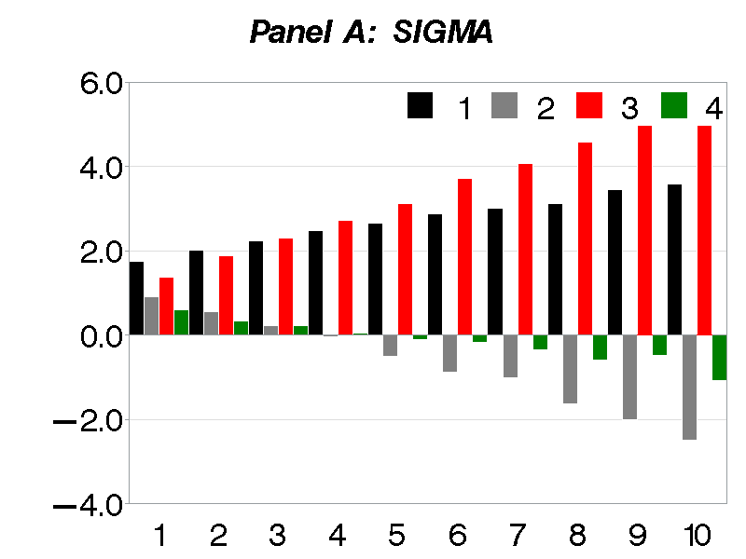 | 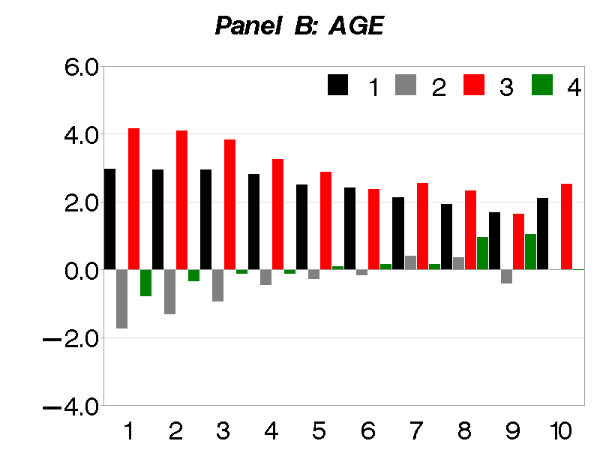 | 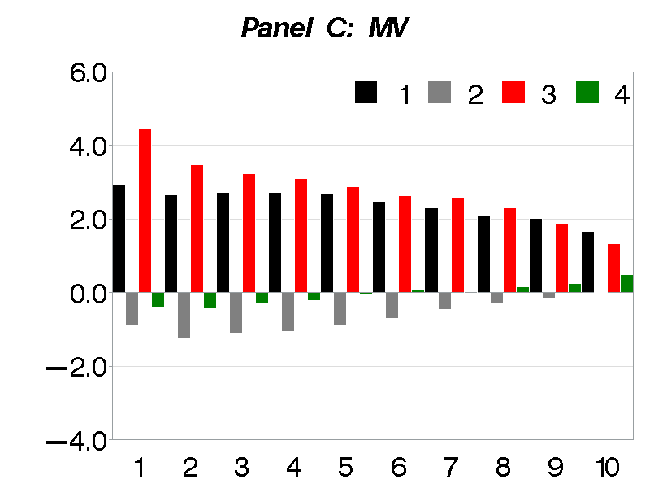 | 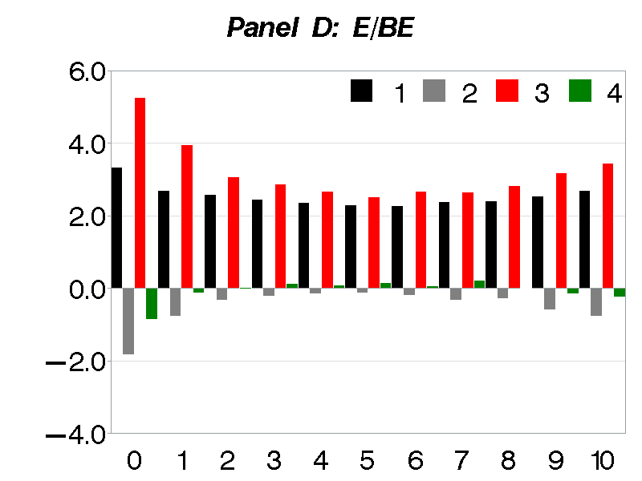
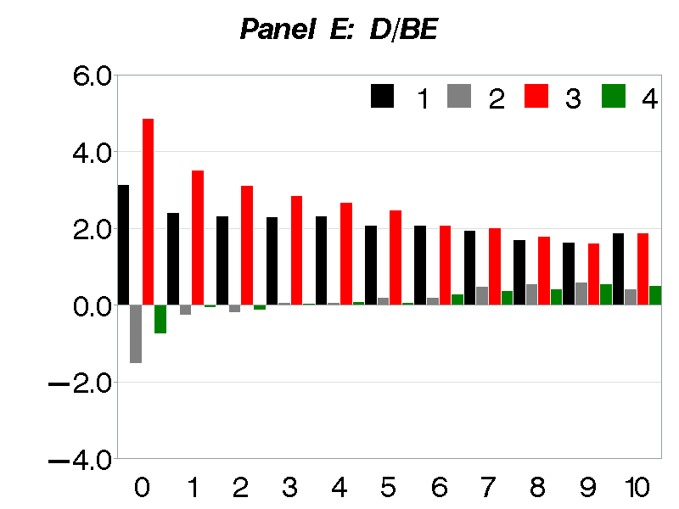 | 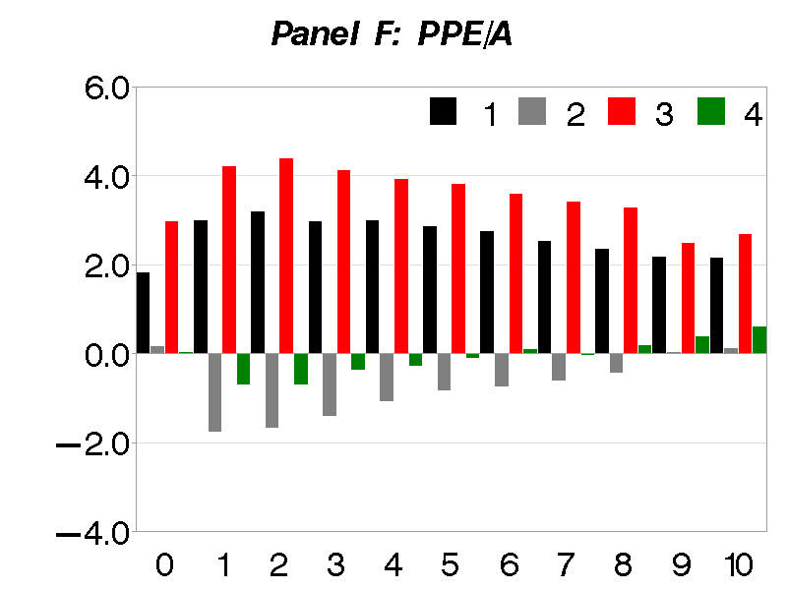 | 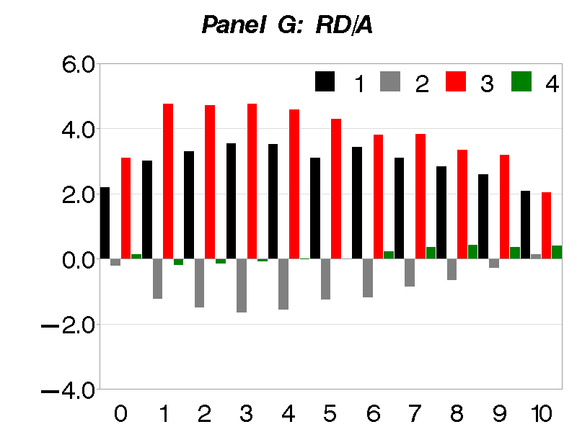

Bali, Cakici, and Whitelaw (2011) discover a new anomaly “MAX effect” where stocks with the highest maximum daily returns (MAX) underperform stocks with the lowest MAX in the subsequent month.
Studies that provide the theoretical support on the contrarian prediction of investor sentiment include Barberis, Shleifer, and Vishny (1998), De Long et al. (1990) and Warther (1995). In contrast, there is little theoretical support available on the momentum predictability of investor sentiment except in China (e.g. Kling & Gao, 2008; Huang et al., 2014).
Baker et al. (2012) show that the contrarian predictability of investor sentiment is more pronounced in hard to value and difficult to arbitrage not only in U.S. but also in global markets.
They argue that behavioural theory provides a clear prediction about the effects of sentiment on cross-sectional patterns since HVHA stocks are more sensitive to sentiment. However, the prediction on aggregate market returns is less clear because safe and easy to arbitrage stock might be inversely related to sentiment which could mute the effects of sentiment on aggregate market returns.
Using the Investors Intelligence bullish sentiment index as a survey-based measure, Clarke and Statman (1998) find that the Bullish Sentiment Index does not predict S&P 500 future returns. Furthermore, Simon and Wiggins (2001) argue that certain problems might arise with the use of survey-based measures. For example, there is a possibility that survey-based measures might be out of date by the time they get published especially in high volatility periods when sentiment is even more important. Furthermore, they argue that responses are weighted equally in survey-based measures irrespective of the amount of funds managed by the survey participants and survey-based measures do not account for the intensity of bullishness or bearishness. In contrast, market-based sentiment measures are observed in real time and indicate both the intensity of sentiment (bullish or bearish) and the market power of market participants (Simon & Wiggins, 2001).
We use Baker and Wurgler ‘sentiment levels’ index and ‘sentiment changes’ index based on orthogonalized proxies. We obtain similar results even if we use Baker and Wurgler ‘sentiment levels’ index and ‘sentiment changes’ index based on raw proxies.
VIX measurement was based on S&P 100 index until 2003.
We thank Professor Wurgler for making these indices available. The sentiment changes index data is available until December 2010; however using Baker and Wurgler (2007), we extend it until December 2014.
The literature shows that arbitrage tends to be difficult and costly for young, small, unprofitable, non-dividend paying and higher intangible asset firms since these firms are more costly to buy and sell (D’avolio, 2002). These firms have higher idiosyncratic variation in returns which makes them riskier for betting (Wurgler & Zhuravskaya, 2002), have higher volatility which could make arbitrage ineffective because of capital constraints (Shleifer & Vishny, 1997), and generally do not pay dividends and therefore their fundamental values are more difficult to estimate making them subject to speculation (Pontiff, 1996).
Baker and Wurgler (2006) also use firm characteristics indicating growth opportunities as a proxy for hard to value stocks i.e. book-to-market equity, external finance and sales growth. They consider extreme deciles (P1 and P10) of these firm characteristics as hard to value stocks and the middle decile (P5) as easy to value stocks. However, Stambaugh, Yu, and Yuan (2012) do not find any significant difference in the return spread of book-to-market results between high and low sentiment periods.
These are unprofitable and non-dividend paying firms, and firms with zero R&D expenses and zero PPE/A values.
It is the difference between the profitable and unprofitable firms, dividend and non-dividend paying firms, firms with positive and zero R&D expenses, and the firms with positive and zero power, plant and equipment assets.
We do not find a significant difference between the returns of firms with positive (high) and zero (low) RD/A values in L/L sentiment state.
We find similar results for other proxies of HVHA stocks; therefore, to save space we only report results for volatility portfolios.
In untabulated results, consistent with Bali et al. (2011) we find that the difference in equal-weighted (value-weighted) raw returns between high and low MAX stocks is -0.58% (-0.75%) per month.
In untabulated results, we find that the difference in equal-weighted raw returns between high and low MAX stocks is -1.41% (0.42%) following high (low) sentiment levels index.
We also sorted stocks based on 2, 3, 4 and 5 daily maximum returns over the past month and find similar results.
Our results remain robust to different proxies of investor sentiment.
Studies that discuss the role of short-sale restrictions in overpricing include Miller (1977), Figlewski (1981), Chen, Hong, and Stein (2002), Diether, Malloy, and Scherbina (2002), Duffie, Garleanu, and Pedersen (2002), Scheinkman and Xiong (2003), Lamont and Stein (2004), Ofek, Richardson, and Whitelaw (2004), Nagel (2005), and Avramov, Chordia, Jostova, and Philipov (2013).
The results in Table 8 shows right signs for all sentiment states, but the results are not statistically significant for L/H state using VIX, and H/H and L/L state using BBS as proxies of investor sentiment.

